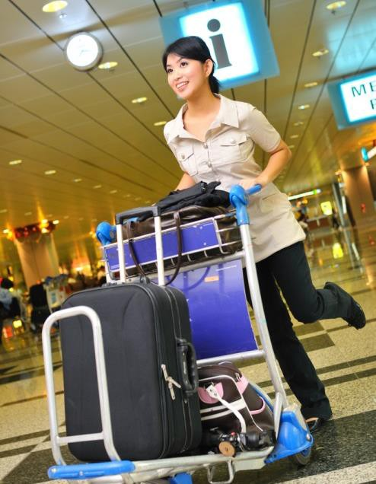

Bain marie
Provide camp site catering
D2.TTO.CL4.18
Trainee Manual

Provide camp site catering

D2.TTO.CL4.18

Trainee Manual





Project Base
William Angliss Institute of TAFE
555 La Trobe Street
Melbourne 3000 Victoria
Telephone: | (03) 9606 2111
Facsimile: | (03) 9670 1330
Acknowledgements
Project Director: | Wayne Crosbie
Project Manager | Jim Irwin
Chief Writer: | Alan Hickman
Subject Writer: | Alan Hickman
Editor: | Jim Irwin
DTP/Production: | Daniel Chee, Mai Vu, Cindy Curran

The Association of Southeast Asian Nations (ASEAN) was established on 8 August 1967. The Member States of the Association are Brunei Darussalam, Cambodia, Indonesia, Lao PDR, Malaysia, Myanmar, Philippines, Singapore, Thailand and Viet Nam.
The ASEAN Secretariat is based in Jakarta, Indonesia.
General Information on ASEAN appears online at the ASEAN Website: www.asean.org.
All text is produced by William Angliss Institute of TAFE for the ASEAN Project on “Toolbox Development for Tourism Labour Divisions for Travel Agencies and Tour Operations”.
This publication is supported by the Australian Government’s aid program through the ASEAN-Australia Development Cooperation Program Phase II (AADCP II).
Copyright: Association of Southeast Asian Nations (ASEAN) 2015. All rights reserved.
Disclaimer
Every effort has been made to ensure that this publication is free from errors or omissions. However, you should conduct your own enquiries and seek professional advice before relying on any fact, statement or matter contained in this book. The ASEAN Secretariat and William Angliss Institute of TAFE are not responsible for any injury, loss or damage as a result of material included or omitted from this course.
Information in this module is current at the time of publication. Time of publication is indicated in the date stamp at the bottom of each page.
Some images appearing in this resource have been purchased from stock photography suppliers Shutterstock and iStockphoto and other third party copyright owners and as such are non-transferable and non-exclusive. Clip arts, font images and illustrations used are from the Microsoft Office Clip Art and Media Library. Some images have been provided by and are the property of William Angliss Institute.
Additional images have been sourced from Flickr and SXC and are used under Creative Commons licence: http://creativecommons.org/licenses/by/2.0/deed.en

File name: TM_Provide_camp_site_catering_240715



Table of contents
Introduction to trainee manual 1
Unit descriptor 3
Assessment matrix 5
Glossary 7
Element 1: Determine camp site catering needs 11
Element 2: Prepare the catering area 39
Element 3: Produce food 59
Element 4: Serve meals 83
Element 5: Clear food and beverage items 97
Element 6: Finalise service session 109
Presentation of written work 123
Recommended reading 125
Trainee evaluation sheet 127
Trainee self-assessment checklist 129

© ASEAN 2015
Trainee Manual Provide camp site catering

© ASEAN 2015
Trainee Manual
Provide camp site catering

Introduction to trainee manual

To the Trainee
Congratulations on joining this course. This Trainee Manual is one part of a ‘toolbox’ which is a resource provided to trainees, trainers and assessors to help you become competent in various areas of your work.
The ‘toolbox’ consists of three elements:
- A Trainee Manual for you to read and study at home or in class
- A Trainer Guide with Power Point slides to help your Trainer explain the content of the training material and provide class activities to help with practice
- An Assessment Manual which provides your Assessor with oral and written questions and other assessment tasks to establish whether or not you have achieved competency.
The first thing you may notice is that this training program and the information you find in the Trainee Manual seems different to the textbooks you have used previously. This is because the method of instruction and examination is different. The method used is called Competency based training (CBT) and Competency based assessment (CBA). CBT and CBA is the training and assessment system chosen by ASEAN (Association of South-East Asian Nations) to train people to work in the tourism and hospitality industry throughout all the ASEAN member states.

What is the CBT and CBA system and why has it been adopted by ASEAN?
CBT is a way of training that concentrates on what a worker can do or is required to do at work. The aim is of the training is to enable trainees to perform tasks and duties at a standard expected by employers. CBT seeks to develop the skills, knowledge and attitudes (or recognise the ones the trainee already possesses) to achieve the required competency standard. ASEAN has adopted the CBT/CBA training system as it is able to produce the type of worker that industry is looking for and this therefore increases trainee chances of obtaining employment.
CBA involves collecting evidence and making a judgement of the extent to which a worker can perform his/her duties at the required competency standard. Where a trainee can already demonstrate a degree of competency, either due to prior training or work experience, a process of ‘Recognition of Prior Learning’ (RPL) is available to trainees to recognise this. Please speak to your trainer about RPL if you think this applies to you.

What is a competency standard?
Competency standards are descriptions of the skills and knowledge required to perform a task or activity at the level of a required standard.
242 competency standards for the tourism and hospitality industries throughout the ASEAN region have been developed to cover all the knowledge, skills and attitudes required to work in the following occupational areas:
- Housekeeping
- Food Production
- Food and Beverage Service
- Front Office

- Travel Agencies
- Tour Operations.
All of these competency standards are available for you to look at. In fact you will find a summary of each one at the beginning of each Trainee Manual under the heading ‘Unit Descriptor’. The unit descriptor describes the content of the unit you will be studying in the Trainee Manual and provides a table of contents which are divided up into ‘Elements’ and ‘Performance Criteria”. An element is a description of one aspect of what has to be achieved in the workplace. The ‘Performance Criteria’ below each element details the level of performance that needs to be demonstrated to be declared competent.
There are other components of the competency standard:
- Unit Title: statement about what is to be done in the workplace
- Unit Number: unique number identifying the particular competency
- Nominal hours: number of classroom or practical hours usually needed to complete the competency. We call them ‘nominal’ hours because they can vary e.g. sometimes it will take an individual less time to complete a unit of competency because he/she has prior knowledge or work experience in that area.
The final heading you will see before you start reading the Trainee Manual is the ‘Assessment Matrix’. Competency based assessment requires trainees to be assessed in at least 2 – 3 different ways, one of which must be practical. This section outlines three ways assessment can be carried out and includes work projects, written questions and oral questions. The matrix is designed to show you which performance criteria will be assessed and how they will be assessed. Your trainer and/or assessor may also use other assessment methods including ‘Observation Checklist’ and ‘Third Party Statement’. An observation checklist is a way of recording how you perform at work and a third party statement is a statement by a supervisor or employer about the degree of competence they believe you have achieved. This can be based on observing your workplace performance, inspecting your work or gaining feedback from fellow workers.
Your trainer and/or assessor may use other methods to assess you such as:
- Journals
- Oral presentations
- Role plays
- Log books
- Group projects
- Practical demonstrations.
Remember your trainer is there to help you succeed and become competent. Please feel free to ask him or her for more explanation of what you have just read and of what is expected from you and best wishes for your future studies and future career in tourism and hospitality.

3
© ASEAN 2015
Trainee Manual

Unit descriptor

Provide camp site catering
This unit deals with the skills and knowledge required to catering in a range of settings within the travel industries workplace context.

Unit Code:
D2.TTO.CL4.18

Nominal Hours:
90

Element 1: Determine camp site catering needs

Performance Criteria
  - Identify tour group requirements
  - Develop menus for the tour itinerary
  - Verify planned menus with management or tour group members
  - Identify equipment and resources required to support menus
  - Stow equipment, resources and supplies for transportation to camp site

Element 2: Prepare the catering area

Performance Criteria
  - Establish the catering area
  - Store food and beverages
  - Establish safe water supply
  - Position catering and dining equipment
  - Position cooking and dining utensils and ancillary items

Element 3: Produce food

Performance Criteria
  - Apply food preparation techniques
  - Apply food production techniques
  - Confirm requirements of itinerary, as advertised

4
© ASEAN 2015
Trainee Manual

Element 4: Serve meals

Performance Criteria
  - Prepare the dining area for service
  - Plate meals for service according to standard food presentation requirements
  - Display food for self-service as required
  - Serve beverages to accompany meals
  - Replenish items throughout service
  - Establish rapport with tour group members

Element 5: Clear food and beverage items

Performance Criteria
  - Clear tables being used by tour group members
  - Clear communal food and beverage service points
  - Tidy food production and service areas throughout service
  - Maintain on-going interaction with tour group members
  - Dispose of unwanted items and materials throughout service

Element 6: Finalise service session

Performance Criteria
  - Dispose of unwanted items
  - Clean and sanitise equipment and utensils used in the storage, preparation, production and service of food and beverages
  - Clean and tidy the food production and dining area
  - Disassemble food related equipment for transport or later use
  - Stow equipment, resources and supplies for transport or later use

5
© ASEAN 2015
Trainee Manual

Assessment matrix

Assessment matrix

Showing mapping of Performance Criteria against Work Projects, Written Questions and Oral Questions
The Assessment Matrix indicates three of the most common assessment activities your Assessor may use to assess your understanding of the content of this manual and your performance - Work Projects, Written Questions and Oral Questions. It also indicates where you can find the subject content related to these assessment activities in the Trainee Manual (i.e. under which element or performance criteria). As explained in the Introduction, however, the assessors are free to choose which assessment activities are most suitable to best capture evidence of competency as they deem appropriate for individual students.

 |  | Work Projects | Written Questions | Oral Questions
Element 1: Determine camp site catering needs
1.1 | Identify tour group requirements | 1.1 | 1. 2 | 1
1.2 | Develop menus for the tour itinerary | 1.1 | 3, 4 | 2
1.3 | Verify planned menus with management or tour group members | 1.1 | 5, 6 | 3
1.4 | Identify equipment and resources required to support menus | 1.1 | 7, 8 | 4
1.5 | Stow equipment, resources and supplies for transportation to camp site | 1.1 | 9 | 5
Element 2: Prepare the catering area
2.1 | Establish the catering area | 2.1 | 10 | 6
2.2 | Store food and beverages | 2.1 | 11, 12 | 7
2.3 | Establish safe water supply | 2.1 | 13, 14 | 8
2.4 | Position catering and dining equipment | 2.1 | 15, 16 | 9
2.5 | Position cooking and dining utensils and ancillary items | 2.1 | 17 | 10
Element 3: Produce food
3.1 | Apply food preparation techniques | 3.1 | 18, 19, 20 | 11
3.2 | Apply food production techniques | 3.1 | 21, 22 | 12
3.3 | Confirm requirements of itinerary, as advertised | 3.1 | 23 | 13

6
© ASEAN 2015
Trainee Manual

Assessment matrix

 |  | Work Projects | Written Questions | Oral Questions
Element 4: Serve meals
4.1 | Prepare the dining area for service | 4.1 | 24 | 14
4.2 | Plate meals for service according to standard food presentation requirements | 4.1 | 25 | 15
4.3 | Display food for self-service as required | 4.1 | 26 | 16
4.4 | Serve beverages to accompany meals | 4.1 | 27 | 17
4.5 | Replenish items throughout service | 4.1 | 28, 29 | 18
4.6 | Establish rapport with tour group members | 4.1 | 30 | 19
Element 5: Clear food and beverage items
5.1 | Clear tables being used by tour group members | 5.1 | 31 | 20
5.2 | Clear communal food and beverage service points | 5.1 | 32 | 21
5.3 | Tidy food production and service areas throughout service | 5.1 | 33, 34 | 22
5.4 | Maintain on-going interaction with tour group members | 5.1 | 35 | 19
5.5 | Dispose of unwanted items and materials throughout service | 5.1 | 36 | 23
Element 6: Finalise service session
6.1 | Dispose of unwanted items | 6.1 | 37 | 24
6.2 | Clean and sanitise equipment and utensils used in the storage, preparation, production and service of food and beverages | 6.1 | 38, 39 | 25
6.3 | Clean and tidy the food production and dining area | 6.1 | 40 | 26
6.4 | Disassemble food related equipment for transport or later use | 6.1 | 41 | 27
6.5 | Stow equipment, resources and supplies for transport or later use | 6.1 | 42 | 28

Glossary

Term | Explanation
4WD | Four-wheel drive
Boning knife | Used for boning raw meat and poultry
Breakfast | First meal of the day served in the morning
Chef knife/Cooks Knife/French Knife | General-purpose knife designed to perform many different Kitchen tasks including slicing, dicing and chopping. Usually 15 cm and 30 cm (6 and 12 inches), though 20 cm (8 inches) is the most common size.
Chiffonnade | Finely shredded/ribbon cut
Cleaver/Butcher Knife | Large knife usually rectangular shape, also known as a hatchet or Chinese Chopper
Cover | Crockery/cutlery/glassware laid at a setting for one person
Custom tour | Tours customised on a one-off basis to meet the needs of an individual client (same as private tour)
Defrosting | Thawing
Dinner | The evening meal
F&B | Food and Beverage/s
FIFO | First In, First Out
FSP | Food Safety Plan/Program
Garnish | An edible decoration used to enhance the overall presentation of a menu item
Inclusions | Things included on/with a tour
Itinerary | A schedule for a tour showing what tour group members will be doing, where they will be going, and the times for each activity
Loading sheets | Checklists prepared by tour operators to guide/monitor the loading of resources onto tour vehicles
Lunch | Mid-day meal

Term | Explanation
Menu item | A dish listed on a menu
Mise en place | (French) To put in place; to get things ready
Paring | Removing the skin
Paring knife | A paring knife is a small knife with a plain edge blade that is ideal for peeling and other small or intricate work. Paring knives are usually between 6 and 10 cm (2½ and 4 inches) long and regarded as an  “All Purpose Knife”
Potentially hazardous foods | High risk food: foods which need to be kept under temperature-controlled conditions in order to preserve their food safety
Rapport | Positive relationship
Recipe | A formula which lists all the ingredients required the method and cooking techniques necessary to prepare a dish
Replenish | Re-supply; provide more of
Sauteuse | Sauté pan with sloped sides
Sautoir | Sauté pan with straight sides
Serrated knife/Bread Knife | A knife where the blade has serrations as opposed to having a straight blade and are able to cut soft bread without crushing it.  And are usually between 15 cm and 25 cm (6 and 10 inches)
Spoodle | Service utensil: combination spoon and ladle
Private tour | Tours developed for a private client designed just to meet their specific needs (same as custom tour)
RCD | Residual Current Device
Regular tour | A standard/scheduled tour
Scheduled tour | A normal/regular tour advertised to the general public and provided on an ‘as is’ basis” see also Standard tour
Slicing knife/Carving Knife | Knife used for slicing and carving meat generally longer and narrower. Slicers may have plain or serrated edges. These knives often have blunted or rounded tips

Term | Explanation
Steel | Tool used to hone a knife
Standard Recipe | List of ingredients and methods of cooking to produce a set quantity of food at a specific standard
Standard tour | Another term for a ‘Scheduled tour’
Temperature Danger Zone | 5˚C to 60˚C: the range within which bacteria multiples most rapidly
Tour brief | A formal document provided by the employer to provide an overview and details of the tour
Tour report | Document completed at the end of a tour providing required details of the tour as requested by the Tour Operator
Utility knife | General purpose kitchen knife
VIP | Very Important Person

Element 1:
Determine camp site catering needs

Identify tour group requirements

Introduction
The first step in providing camp site catering is to determine tour group requirements.
This section explains why this is important, discusses camp site catering staff, describes how it can be achieved, and identifies examples of requirements which are often listed by groups.

Why this is important
It is important to identify tour group requirements to:
- Place the tour to be conducted into its true context – by putting the tour, inclusions and catering into perspective as this applies to the individual tour.

A primary requirement here is to determine if the tour is:
  - A private/custom tour – see immediately below
  - A standard/scheduled tour – see immediately below
- Optimise likelihood of meeting tour group expectations – in relation to:
  - Special requests made by customers in relation to the tour – some (but not all) Tour Operators will accommodate certain special requests for menu items and/or beverages if they are cost neutral and if they can be fitted in to other constraints such as itinerary, local conditions, and available resources
  - Inclusions (in this case promises made about meals, dishes, food and beverages) which have been promoted as being part of the tour – in advertisements for the tour as presented in the media, tour brochures and other promotional materials
- Accommodate feedback received – from:
  - Previous tour group members – on the basis of:
    - Formal written feedback received
    - Issues raised during the end-of-tour discussion which should be standard for every Tour Group to have with their tour group
    - Topics and issues mentioned as part of the standard Tour report generated by tour leaders and tour staff (including catering staff) when a tour has completed
  - Local/host communities where camps have been set-up and where catering has been provided

- Discharge legal obligations – as imposed by:
  - Contracts for the tour which have been developed/entered into – especially those attaching to custom/private tours
  - Legislation relating to false advertising
- Identify issues which may be important to individual tours and/or tour groups – which may include:
  - Special diet needs of tour group members
  - Allergies which need to be accommodated
  - Cultural preferences for food
  - Religion-based requirements
  - Specific focal points of a tour – such as:
    - ‘Taste of the Country/Region’
    - Tours with a certain food and/or beverage-based focus
    - Camp fire nights
    - Barbecue nights
    - Spit roasts
    - Tours highlighting local cooking styles
  - Timing requirements for meals and refreshments
  - Personal and/or group preferences – for:
    - Types of food and beverages used
    - Cooking styles
    - Serve sizes.

Private/custom tours
Private/custom tours are tours which are:
- Developed under contract with a client (individual or group)
- Customised on a one-off basis – in terms of:
  - Focus
  - Interpretive activities
  - Commentary
  - Itinerary
  - Cost
  - Inclusions
- Designed specifically and totally to meet the stated/identified needs of the individual client
- Run at a time and date determined by the client
- Planned and prepared/organised on a tour-by-tour basis.

Implementation requirements
Implementation requirements for private/custom tours:
- May be based on implementation requirements for standard tours – planning of these custom tours may have been based around a standard tour for the purposes of efficiency or because scheduled tours cover/address much of the requirements for the private tour
- Will often be unique in nature – given the one-off nature of these tours
- Can often require contact with the client to:
  - Discuss and interpret requirements
  - Confirm requirements
  - Clarify issues
  - Obtain recipes
  - Capture details of special requests, allergies, requirements based on culture, religion and other factors.

Standard/scheduled tour
A standard/scheduled tour (also known as a ‘regular’ tour):
- Is the normal tour advertised generally by the company
- Is available to all/members of the public
- Is the type of tour most people take
- Operates using the same itinerary every time
- Features the same interpretive activities, inclusions and scripted commentary every time
- Is essentially the same tour for all tour group members, time-after-time – subject to seasonal changes and other foreseeable and unforeseeable factors

Implementation requirements
Implementation requirements for standard/scheduled tours:
- Is standard – in terms of:
  - Preparing required resources
  - Using standard checklist and documentation for loading and other operational matters
  - Ensuring the same tour delivered previously is replicated this time to maintain quality and consistency of delivery, and retain the image/profile of the business
- May require checking to determine if any special requests have been made – and/or are approved or are required by management
- May require adjustment – to accommodate the changes (in this case, to the standard menus) brought about by seasonal factors as food move in and out of season, and as the prices of ingredients dictate.

Camp site catering staff

The nature of camp site catering staff can vary between operators and between individual tours.

Relevant factors
Factors which may dictate the composition of camp site catering staff will be:
- Size of the tour group – tour group numbers
- Service style – that is, whether catering is to be:
  - Self-catered to some/any extent – where tour group members cook their own meals from provisions provided (and perhaps prepared) by the catering staff
  - Self-service – where catering staff prepare and present the food and tour group members serve themselves
  - Fully-served – where the food is prepared, served to and cleared from the tour group
- Menus/menu items to be used for the tour
- Ambience, class and style being portrayed by the tour operator – for the tour
- SOPs of the business – in relation to the way they operate catering for tours
- Special requests made by tour group members – including any requests which have been supported by extra funds to enable more/different staffing personnel and/or staffing levels.

Staffing
Staff for campsite catering may feature:
- Tour group leaders who double as the caterer for the group – this means they will lead the tour, do the commentary, conduct activities and also:
  - Set up the camp and catering requisites
  - Prepare and cook the food
  - Serve the food and drinks
  - Clean up after the meals
- Specialist staff who accompany the tour and travel with the group – such as:
  - Cooks
  - Kitchen hands
  - Waiters
- Specialist staff who precede the tour group and set up the catering facilities at the camp in advance of group’s arrival – such as those mentioned above, plus:
  - Labourers – to set-up tents/marquees
  - Technicians – to test, confirm or treat water supply
  - Administrators – to negotiate with land managers/local communities. These people will break camp after meals are finished and either:
  - Move to the next location and prepare the next meal
  - Leap-frog another crew/team and set-up for the meal after next
  - Return to the head office for other deployment
- People from local communities – there may be an arrangement where local people are employed in various roles to assist with cooking, service, entertainment, interpretive activities and other support roles.

How to identify what is required

Those involved with camp site catering for tours can identify what is required for an upcoming tour by:
- Talking with management – who organised to tour and/or prepared the itinerary, budget and the advertising for the tour
- Speaking with those (for example, personnel from sales and marketing) who developed the requirements for a custom tour with the client – because they will have first-hand knowledge about what is required as a result of talking with the tour group
- Reading the standard documentation for a scheduled/standard tour – this means taking the time to read and note the details contained in:
  - Itineraries
  - Advertisements and promotional material for the tour
  - Tour briefs
  - Tour-specific catering checklists and loading sheets
  - Budgets
  - Tour Reports
- Reading the contract prepared and signed for a custom/private tour – to identify the specifics which have been requested, negotiated and agreed with the tour group/client
- Talking to Tour Guides, Tour Group Leaders, Cooks and Catering Staff who have catered for previous identical and/or similar tours – to get their thoughts and ideas about what is needed and what is involved
- Talking directly with tour group members who have booked for the tour – to identify their individual requirements, expectations and/or preferences
- Reading ‘Special Requests’ made by tour group members – using a range of options as provided by the individual tour operator, such as:
  - Website options
  - Social media options
  - Hard copy forms
- Going on a tour as a ‘working’ tour group member – to gain a personal, first-hand impression of what is provided, when it is provided and how it is provided.

Examples of what could be required
The following provide examples of the variety of requirements which need to be identified and understood as an integral part of determining camp site catering needs and gives an insight into why this knowledge is important for the planning process:
- Destinations – it is necessary to know the itinerary for the tour with reference to:
  - Learning where the tour is going – in terms of towns, cities, regions or other nominated areas, sites or locations
  - Identifying locations for meals – as some sites have catering facilities in place and some do not, and some can provide ingredients/supplies for meals and others can not

  - Determining facilities available at the camp site(s) to be used at the destinations – tour operators tend to use camp sites/locations/providers they have used previously so they are dealing with a ‘known quantity’.

To find out the available facilities:
    - Speak to catering staff who have used those facilities before
    - Contact the camp site owner/operator to discuss what is available
  - Identifying locations for refreshments to be provided as part of the
tour – and whether these are to be provided through a local provider, on/from the tour vehicle, or in a more formal and substantial form requiring establishment of (for example) tent and catering facilities for morning teas, afternoon teas and/or suppers
  - Identifying which, if any meals, are to be provided by third party providers – while it is common for some tours to provide all their own catering it is also common for some of the meals to be taken at destination locations catered for by other venue operators (hotels, restaurants, tourist attractions, host communities) perhaps as part of a side- tour or as part of an advertised inclusion, interpretive activity or tour experience
  - Determining some menu items – because sometimes tour groups expect certain dishes at certain locations/destinations
- Duration of the tour – considerations here include:
  - Timing of the tour – in respect of the time of year the tour is conducted as this will influence the availability of local, fresh produce
  - Day of the week the tour leaves – as there can be a need to pre-arrange the delivery of some foods/provisions in advance (on the Friday) where a tour departs on a Saturday or Sunday
  - Length of the tour – to identify:
    - Number of nights the tour is for
    - Number and date and time of meals to be catered for
    - Number and date and time of meals to be provided by third parties
    - ‘Free time’ – where tour group members have been advised in advance they will be required to buy their own meal from a local provider as they see fit/to suit their own taste or budget
    - Number of overnight stays – which indicate need for dinner and breakfast for the group
    - Time when tour returns – to determine if lunch is required on the final day of the tour
- Routes to be taken – this is important because:
  - It may be possible to acquire better quality provisions from a provider along the way
  - It may be possible to buy cheaper items on route
  - Some provisions may only be able to be acquired from local providers along the tour route
  - The tour operator may have a contractual arrangement with certain providers to supply the tour and charge back to head office

  - 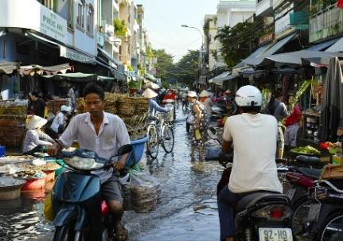The tour may feature a service whereby the catering staff may cook prepare and cook fish and game caught by tour group members
- Type/name of the tour – because this will/may:
  - Give a context or general ‘flavour’ for the menu items which can/must be selected for the tour
  - Provide direction for service standards
  - Indicate a theme which needs to be integrated into the catering
  - Highlight certain meals to be prepared at nominated dates/times/locations on the tour
- Transport available for the tour to move equipment, resources and supplies – common options are:
  - All catering requirements are loaded onto the standard tour vehicles as part of the standard loading for these vehicles
  - Separate catering units (vans, trailers, trucks [for tents, marquees and large catering equipment], portable cool rooms) are provided in addition to the passenger-carrying buses or 4WD vehicles
- Equipment available for the safe storage of perishable food – this may relate to:
  - Providing portable cool rooms – which may be trailer- or truck-mounted
  - Using smaller portable (gas and/or low voltage) refrigeration units
  - Generator-powered and/or solar-powered refrigeration and/or freezer units
- Staffing levels for the tour – this relates to:
  - Identifying the number of staff the tour operator has assigned to the tour based on tour group numbers and labour budget imperatives
  - Finding the actual names of the individual personnel who have been assigned to the tour – it is good to know in advance exactly who will be provided the labour for the catering because it is a fact of life some staff are better than others/have more skills, and some staff have strengths that other staff do not
  - Being able to think about (in advance) what the staffing levels/staff members will realistically allow to be provided in terms of food/menu items and service
  - Pre-planning roles and responsibilities for those who have been allocated to the tour
  - Providing necessary pre-tour training for certain employees so they are proficient when on tour
- Number of people who have to be fed – this relates to determining:
  - Number of tour group members for each service session
  - Number of tour and support staff who have to be fed for each service session
  - Age and gender of those who need to be catered for – as this impacts selection of menu items, style of food and serve sizes
- Previous history of the group – if the group has toured with the same tour operator previously it is essential the feedback forms, Tour Reports and any other comments obtained from that group are accessed to ensure:
  - Previous problems which were identified are avoided/not repeated
  - Suggestions for improvement are accommodated wherever possible
  - Any issues raised are addressed to the best of the ability of the organisation.

Develop menus for the tour itinerary

Introduction
When a clear understanding of the context of and requirements for the tour has been obtained, the menus can be prepared.
This section discusses considerations which need to be taken into account when preparing menus for tours/camp site catering.

Standard menus
For most tours where there is a need for camp site catering there will be an established range of menus which have been developed.
These menus will have been trialled, tested and refined over time and reflect meals which:
- Have proved to be tasty and acceptable to tour group members
- Can be prepared within budget
- Are able to be prepared using available equipment
- Can be cooked by the existing staff – without the need to hire new/extra staff or train/re- train staff
- Provide a suitable range of food (and beverages) – so there is a variety of:
  - Basic ingredients
  - Cooking styles
- Enable differences (where required) in terms of:
  - Menu types
  - Service styles. These standard menus:
- Will often vary between different tour types – to reflect the nature of the tours and the available resources
- Will usually stay the same for the same types of tours – this facilitates staffing of catering crew, ordering/purchasing of ingredients, preparation of loading sheets, loading of vehicles
- Will have standard recipes to guide the preparation of each menu item – see ‘Standard recipes’ below
- May dictate the dishes which can be offered on a tour – there may be no room for catering staff to change the menu items listed.

Where changes to dishes are being considered there can be a need to:
  - Generate a new draft standard recipe
  - Cost the new/revised recipe
  - Demonstrate the cost meets acceptable budget constraints for the dish, meal or tour.

Standard recipes
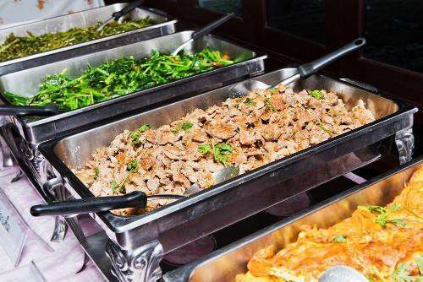A standard recipe is a precise record of ingredients, method, serving instructions and cost of a menu item.
There are several variations on the layout and content of a standard recipe but they should include:
- Name of the dish/menu item
- List of ingredients
- Required quantities of each ingredient
- Specific preparation guidelines
- Garnish and service details
- Portion sizes
- Costs.
Standard recipes are used because they standardise the production of recipes meaning that regardless of who makes them there will be:
- Consistent quality – items always taste the same
- Consistent presentation – dishes always look the same
- Consistent portion size – each recipe will always produce the same number of customer serves/quantity
- Known cost – for each menu item and each serve of each item
- Optimal customer satisfaction – based on the development of a recipe which has changed over time to reflect customer feedback about taste, portion size and other relevant criteria.

Budget
There will always be a need for tour menus to be developed in accordance with budget limits for the tour.
Keys in this regard are:
- As identified above, the use of standard recipes greatly assists in this regard
- The budget will/may vary depending on tour group numbers – greater numbers mean more money is available for ingredients
- There may be a need to substitute expensive ingredients for less expensive ones where funding is tight
- There may be a need to swap one dish for another where the cost prices are prohibitive
- It may be possible to limit the costs of one dish so extra money can be spent on another – but the nett result must be ‘cost neutral’ meaning the end result must not entail extra cost to the business
- Reducing serve sizes to lower cost per head where the cost of ingredients has risen unacceptably
- Negotiate dishes required by custom/private tour groups before a final price for the tour is given – so the cost of ingredients can be appropriately factored into the final price

- Recover extra costs from tour group members who are participating in scheduled tours where they have special catering requests which incur additional expense for the tour company.

Climate
The menus produced need to reflect – at least to an extent – the expected climate for the tour.
The climate is traditionally the ‘expected’ climate for the time of the year the tour is being conducted based on experience and historical evidence.
In general terms (which are always subject to cultural and special requests):
- Hot weather means more cold food and chilled drinks
- Hot weather is suitable for preparation/presentation of frozen dishes/desserts
- Cold weather indicates a need for hot food.

Timing of meals
Menus need to be planned:
- Day-by-day
- Meal-by-meal.
There is a need for menus and meals to match the itinerary for the tour and any other advertised statements or promises made.
This may mean there is a need for:

Breakfast
Breakfast is the first meal of the day and commonly served on tour between 6:00 and 8:00am.
In addition to local traditional breakfast dishes the following variations are common and popular.

Continental
‘Continental’ is a term used to describe what might be
available in France or Germany as being from Continental Europe as opposed to England.
It typically comprises a small. Light breakfast featuring bread/toast, rolls or pastry such as croissants and baguettes served with a preserve or honey and accompanied by coffee.

English breakfast
This is a large hot breakfast which can include fried bacon rashers, eggs (scrambled, poached or fried), grilled lamb cutlets, grilled tomatoes, fried mushrooms, kedgeree (curried fish and rice), fried kidneys, livers, and toast.
There is also a cold part of the English breakfast which includes the continental breakfast as well as cereal, and a selection of fruit and juices.
Tea and/or coffee is also served.

American
This is similar to the English breakfast except hot cakes (pancakes) are also served with whipped butter, and maple syrup sometimes with bacon rashers.

Morning tea
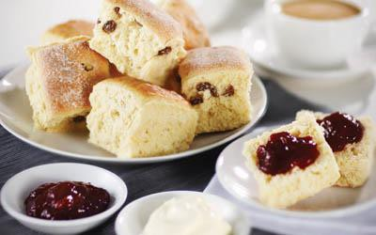Morning teas may be served between 10:00 and 11:00am.
Morning tea may include a selection of sandwiches, scones with jam and cream, small cakes, pastries and fruit plates.
These are accompanied by tea, coffee, fruit juice and cold drinks/water.

Lunch
Lunch is the mid-day meal and normally served between noon and 2:00pm. It is more often than not considered a utilitarian meal.
In other words, it serves to satisfy hunger, and get people back on tour. Most lunches offer limited courses (two is common, three is maximum).
There are no hard and fast rules governing what can or cannot be served at lunch with pasta, wet dishes, roasts, salads, grills and sandwiches being acceptable and popular choices.

Afternoon tea
Served usually between 3:00 and 5:00pm, it is similar to morning tea, although there is sometimes more emphasis on cakes.

Dinner
Seen as the main meal of the day it is normally served any time between 6:00 and 9:00pm. The timing of dinner tonight often reflects the starting/departure time for the tour tomorrow.
The dinner tends to be more relaxed than lunch and dishes are often more elaborate with more courses (or certainly three courses: perhaps entrees, soups, main courses, hot and cold desserts) offered.
There is really no limit as to what can be served with a great variety of options available from (to mention a few) pasta, game, poultry, meat (all types), seafood

Supper
Suppers are often not a feature of tours/camp site catering but may be served late in the evening before the tour group retires for the night.
They are traditionally simple and easy to prepare.
They may feature hot and cold dishes include snacks, sandwiches, smoked salmon, desserts, coffee and chocolates.

In addition
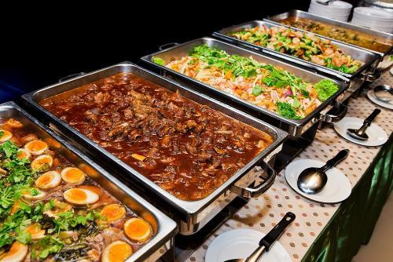Most tours where there is camp site catering can require:
- Snacks/refreshments at designated times on nominated days – to replace and/or supplement standard meal times
- Beverages ‘at all times’ or between given times every day – so tour group members can have ready access to liquid refreshment.

Special needs

These can include:
- Requests for personal favourites of individual tour group members
- Dishes to celebrate special occasions – anniversaries, birthdays, holidays, sporting events, personal achievements
- Accommodation of known cultural dietary requirements
- Life-styles preferences of tour groups which have to be met – such as those who want a macro-biotic diet, and people who subscribe to the various vegetarian options: see below
- Culturally-based food preferences and requirements
- Dishes and/or foods which need to align with religious preferences or restrictions
- Medical issues necessitating certain foods and/or cooking styles – see below.

Vegetarian options
Vegetarian options can relate to:
- Lacto-ova vegetarians/Ova-lacto vegetarians – these are the majority of vegetarians: they eat dairy products and eggs but not meat of any kind (meat, poultry or fish)
- Lacto-vegetarians – they do not eat meat, poultry or fish: they do not eat eggs but they do eat dairy products
- Pescatarians – people who do not eat meat, poultry or animal flesh but do eat fish
- Vegans – this definition is open to various definitions so it is best to check exactly what the person means when they say they are vegan.
Generally a vegan is someone who does not eat meat, poultry, fish, eggs or dairy products and does not eat foods derived from animals (such as gelatine).

Medical issues
There can be a need to create menus which accommodate the following medically-related issues:
- Requests for low-salt meals
- Requests for low-sugar/no sugar meals – for diabetics
- Requests for lactose-reduced milk – for those who are lactose intolerant
- Requests for gluten-free food – from patrons who have celiac disease
- Requests to cater for people with various food allergies.

Nutritional balance
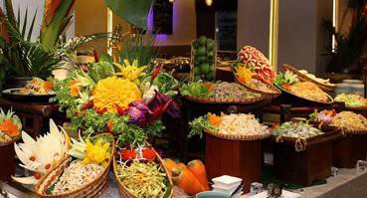In reality ‘nutritional balance’ is a secondary consideration for many tour menus unless the tour is one where members are expected to exert a lot of energy in terms of hiking, playing sport or engaging in activity on a regular and sustained basis.
A nutrient is a source of nourishment found in food and they are needed by the body to:
- Provide fuel for energy
- Provide materials for growth, repair and maintenance
- Provide special elements needed for body processes. The nutrients that the body needs are:
- Carbohydrates
- Protein
- Lipids
- Vitamins
- Minerals.

Carbohydrates
Carbohydrates are the human body's main source of energy, so it is important that the diet includes enough to provide energy for basic functions such as breathing as well as the physical activity of the day.
Carbohydrates are classified as either:
- Simple carbohydrates
  - Foods high in sugars – for example, sugars found in cane (sucrose), fruit (fructose), milk (lactose), honey
- Complex carbohydrates – the starches found in plant foods such as potatoes, rice, bread, pasta, noodles.

Protein
Protein is needed to produce, repair and maintain all the cells throughout the body (hair, fingernails, muscles, blood).
Many foods contain a good source of protein:
- Animal proteins
  - Meats, poultry, seafood, game, eggs, dairy
- Plant protein
  - Some plant foods also contain good sources of protein such as soy products like tofu or bean curd and plant foods such as grains, nuts, seeds and legumes.

Lipids
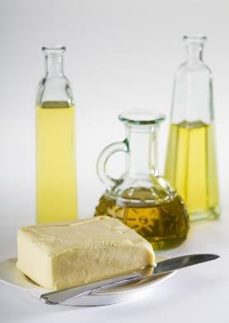Lipid is the combined term used to describe foods that are a fat or an oil.
Lipids are used in the body in the structure of cells, to provide insulation, to assist in the transport of fat soluble vitamins and can be used as a source of energy.
Lipids can be classified as:
- Fats – these are usually solid at room temperature and come from birds – for example, butter, chicken fat, lard
Plant-based coconut and palm fats are exceptions.
- Oils – these are normally liquid at room temperature and made from plants, seeds and fruit.

Vitamins
Vitamins are micronutrients, meaning they are only needed in very small amounts.
Eating a balanced diet as outlined in dietary guidelines (see http://www.nhmrc.gov.au/_files_nhmrc/publications/attachments/n31.pdf) will provide most customers with sufficient quantities of these vitamins.
Vitamins are divided into two groups based on their solubility:
- Water soluble
  - Vitamins C and the B complex vitamins
- Fat soluble
  - Vitamins A, D, E, K.

Minerals
Minerals like vitamins are also micronutrients and only needed in very small amounts.
Again eating a balanced diet as outlined in dietary guidelines will provide sufficient quantities of the 17 minerals that the body needs for health.
Each of the minerals plays an important role in the body’s daily processes. There are 4 minerals that are often discussed when considering health, they are:
- Iron
  - Required for the production of red blood cells
  - Assist in the transport of oxygen
- Calcium
  - Essential for strengthening bones and teeth
  - Play a role in muscle functioning and blood clotting
- Sodium
  - Essential in balancing fluid in the body
- Zinc
  - Needed for growth.

Nutritional balance means that meals include foods from each of the above groups – plus fibre and water – which provide essential nutrients.
A balanced diet will contain small amounts of fats, oils, sugar-rich foods and salty foods as well as foods from core groups as follows:

Grain foods | Vegetables and legumes | Protein rich foods | Dairy foods and dairy alternatives | Fruit
Wheat Products  - Breads  - Pasta  - Cous cous  - Noodles  - Cracked wheat | Fresh vegetables  - Cooked  - Raw (salad) | Meat (lean)  - Beef and veal  - Pork  - Lamb  - Goat  - Game | Milk (reduced fat)  - Fresh  - Canned  - Powdered | Fresh  - Cooked  - Raw
Rice products  - White, brown  - Noodles | Canned (no added salt) | Poultry (lean)  - Chicken  - Duck | Yoghurt  - Plain  - Flavoured | Canned (no added sugar)
Corn products  - Polenta | Frozen | Seafood  - Fish  - Shellfish | Cheese | Dried
Oats  - Porridge  - Muesli | Dried  - Dried peas  - Dried beans  - Lentils | Soy products  - Tofu  - Bean curd  - Tempeh | Alternatives  - Calcium- enriched soy | Juice
Other grains  - Barley  - Millet  - Quinoa |  | Other protein rich foods  - Nuts and seeds  - Pulses

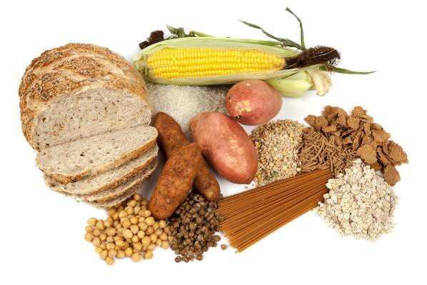

Availability of supplies
The menus for each day and/or individual meals can sometimes depend on the availability of supplies.
This highlights not all catering ingredients (or catering equipment) will necessarily be carried with the tour.
In some cases, menus for certain days and meal times will be developed to take into account:
- Ingredients which may be able to be obtained en route – this can mean:
  - Better quality items may be able to be acquired along the way
  - Cheaper goods may be available along the route
  - Unique/local goods may only be available along the course of the tour
  - The tour operator has a commercial agreement with a third party supplier to provide certain items
- Equipment and facilities available at the camp site destination – which, for example, may mean:
  - Spit roasts are cooked only at a site where there is spit roasting equipment available on site
  - A more formal service may only be provided at camp sites where there are tables and chairs and covered dining areas.

Beverages
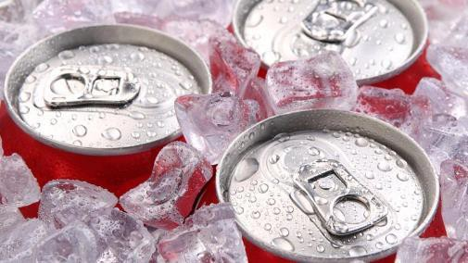Beverages are a standard party of all camp site catering.
The standard offering of drinks may feature:
- Proprietary brands of soft drink
- Fruit juices
- Tea and coffee
- A basic range of alcoholic beverages – beer, wine and spirits. Service of alcohol must always:
  - Comply with host country legislation
  - Meet restrictions which may be applicable in host communities. Extra beverages may be stocked to:
- Accompany certain dishes
- Meet special requests
- Accommodate pre-paid arrangements made by tour group members.

On-tour transportation
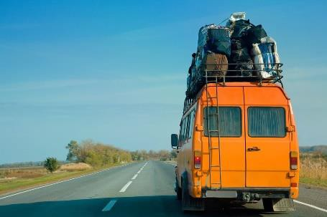Development of some menus will also need to take into account whether the meals are to be prepared at the camp site for transport to other destinations as part of short and day tours from the camp site.
This consideration may need the following to be addressed:
- The carriage of meals by own tour vehicles to a remote location away from the camp site
- Transfer of meals to another tour for transport by them for use on their tour
- Carriage of meals by individual tour group members for their personal use throughout the day.

Food storage capacity
There is always limited storage capacity for food storage when providing camp site catering simply because it is off-site catering and does not enjoy the same type and extent of resources available in most other commercial catering undertakings.
This issue necessitates consideration of:
- Storage capacity on catering and tour vehicles for storage of dry, refrigerated and frozen food prior to its preparation
- Capacity in catering and tour vehicles to store prepared food after it has been cooked and is waiting to be served/eaten
- Storage protocols which must be adhered to regarding prepared food – for later re-use and/or re-heating for service.
Note: some operators put a total ban on the storage of prepared food for later service, due to food safety concerns.
- Storage equipment provided/available on-site at camps where catering is being undertaken.

Verify planned menus with management or tour group members

Introduction
There can be a need to verify menus developed for a tour prior to providing them.
This section looks at why this is necessary, presents timing of the action and describes how it may take place.

Why is this necessary?
Note: for standard tours there is rarely a need to confirm menus; there is more of a need to do this with custom tours.
There can be a need to verify menus planned for a tour (prior to providing them) in order to:
- Comply with internal organisational protocols – it may be SOP in businesses that this occur for:
  - Every standard tour
  - Just for custom/private tours
  - Nominated tours – especially those:
    - Involving new clients
    - Where VIPs are involved
    - To new destinations, on new routes
- Keep promises made to tour group members – that they will (for example):
  - Be consulted in relation to the catering
  - Have an opportunity to suggest/identify menu items
  - Be able to notify specific issues – medical, cultural, lifestyle and similar
  - Be presented with a range of options from which they can choose
  - Be presented with draft menus before they are confirmed as ‘operational’ for the tour
- Meet customer expectations – that:
  - The tour operator is customer-focussed
  - Individual preferences will be (to some extent) accommodated
  - Their tour is (or can be) a unique experience from a catering perspective
- Discuss arrangements/planned menus with management or administration – to:
  - Check food cost is within budget
  - Confirm menu items are regarded as sufficient and suitable
  - Learn of factors which may impact the proposed menus – such as (for example):
    - Clash in need to use limited equipment
    - Transport restrictions due to vehicle breakdown

    - Unanticipated staff leave/absences (cooks, catering staff)
  - Identify need to revise/modify menus as required
  - Obtain final approval to proceed with the planned menus
- Check with Stores and/or Purchasing – that:
  - The required resources (food and equipment) are available
  - Required resources can be ordered and obtained by the required date.

When?

The need to verify menus for a tour needs to occur ‘sufficiently in advance’ (say, 7 – 10 days before departure) of the tour to enable sufficient time for:
- Planned menus to be revised, if needed
- Recipes to be developed, where required
- Recipes to be trialled and tested
- Resources and ingredients to be ordered
- Resources and foods/beverages to be delivered
- Loading sheets to be prepared
- Resources, foods and beverages to be packed and stored ready for travel.

How?
The verification process should comprise:
- Face-to-face meeting with relevant people with appropriate discussions
- Use of handouts to show menus, recipes, costs and other matters as needed.
Where there is a need to communicate with tour group members in this regard it may be acceptable to:
- Use telephone contact to discuss matters
- Send emails with relevant attachments of menus, recipes, photos of dishes, lists of options for menu items, indication of additional costs to cover special requests.

Identify equipment and resources required to support menus

Introduction
Effective camp site catering necessitates having the food and the equipment needed to prepare, cook, present and clear/clean all the planned menu items and beverages.
This section looks at how to determine the equipment and resources needed to support these menus.

Determining requirements

Basic requirements
Planning and preparation for camp site catering requires:
- Identifying the type and quantity of physical resources (equipment and utensils) needed to produce and serve the food and beverages
- Identifying the type and quantity of ingredients needed to prepare and serve all identified menu items and drinks
- At least two people to do the planning, identification of items and ingredients and perform/check the calculations.

Factors to consider
Factors to consider in this regard are:
- Determining facilities and equipment available at the camp site – many tours visit the same camp sites every time so there is often a good understanding of what cooking equipment, storage, utensils, water and infrastructure is available.
Menus for these tours should be based on these available facilities and equipment (where possible) to reduce the need to carry/transport items.
Where a new camp site is being used, options to determine available facilities and equipment are:
  - Visit the site in advance to inspect it
  - Contact the owners/operators/body in charge and:
    - Enquire about what is available
    - Make arrangements for required items to be supplied
- Applying the concept of ‘target planning’ – this means:
  - Using the approved menus and the standard recipes which support them for the individual menu items as the basis for calculating ingredients and food quantities required.
The standard recipe will indicate the ‘Yield’ for the recipe (that is, how many people the recipe will feed) – this should be used as the basis for the calculation.
There is often a need to ‘adjust’ the recipe to arrive at the target number of serves/portions (see ‘Adjusting a recipe’ below).

This approach ensures all the required ingredients (but no more, no excess) will be identified and obtained and packed for the tour.
  - Using the approved menus and the standard recipes which support them for the individual menu items as the basis for calculating cooking equipment and utensils required.
The standard recipe will indicate the cooking method for the menu items for the tour and only these items need to/should be packed.
Attention needs to be paid to ensuring increased equipment is identified and loaded where standard recipes have to be adjusted upwards – for example, increasing the yield may require a bigger pot, more pans or a different piece of cooking equipment.
- Factoring in provisions/ingredients available locally – there can be a need to calculate the food/beverage requirements for a tour taking into account items which are available at the site or en route.
This:
  - May be SOP for some tour operators and/or some tours but not for others
  - May not be a reliable option – there is always uncertainty when having to rely on a third party to supply food for a tour group
  - Could be part of a contractual arrangement with a local and reliable food supplier or catering venue
  - Reduces the need to load and carry certain items – which saves on weight and space
  - May enable fresher produce to be served at more locations – as opposed to carrying/using frozen, dry or dehydrated alternatives
- 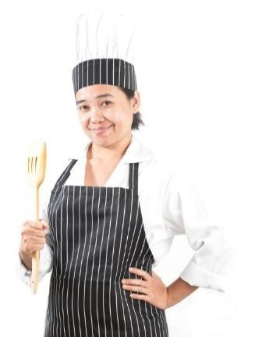Preparing a standard cooking kit – many camp site catering crews develop and carry a supplementary kit for all tours they service.
This is usually a box (or two or more) of basic utensils and ingredients – these items are taken over-and-above the items identified and carried as a result of the target planning done (above).
These kits have evolved over time in response to situations where catering crews have discovered a need for items they have previously forgotten or not considered packing for a tour, but found they needed/could have used.
The kit might carry, for example:
  - The cook’s favourite knives/knife kit
  - Matches and/or lighters
  - First aid kit
  - Paper towels
  - Tea towels
  - Cleaning cloths
  - Chopping boards
  - A range of cooking utensils – such as strainers, ladles, slotted spoons, carving forks, spatulas and similar
  - Salt and pepper
  - A range of proprietary sauces
  - Cooking oil
  - Spice kit/rack

Adjusting a recipe
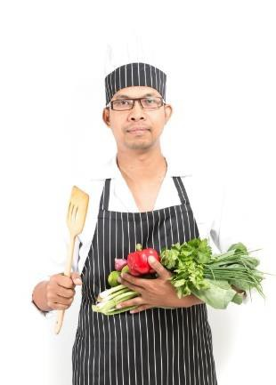Adjusting a recipe means altering the quantities of ingredients to allow the production of more or less of a dish but retain the required flavour, appearance and other characteristics of the dish.
For example, there may be a recipe for 50 portions of Chicken Marengo but only a need to produce 20 serves.
Or there may be a recipe that yields 50 serves but there is a need for 150 serves.
Special care needs to be taken when adjusting a recipe because mistakes can easily occur when calculating the new/revised quantities: there is no point getting nearly all of the calculations right, and messing up just one or two.

Sample calculations
Consider the above Chicken Marengo example 20 serves were wanted from a recipe designed for 50: this means there is a need for 20 out of 50 serves, which means 20/50 of the recipe, or 2/5ths of the quantities.
To express 2/5ths as a percentage (and this is preferable because percentages are easier to use), simply use the calculator as follows:
2 ÷ 5 = 0.4
0.4 x 100 = 40%
This means if all the ingredients in the original 50-serve Chicken Marengo recipe are multiplied by 40% then the recipe/quantities for a new recipe can be gained.
Alternatively, if there is a recipe for one litre of a sauce and three litres are needed, simply multiply all the ingredients by three to get the new recipe.

Foods and beverages

Food
The type of foods carried for a tour need to reflect the duration of the tour – for example, an overnight tour where catering is only required for dinner on Day 1 and breakfast on Day 2 would focus more on fresh food than a 14-day tour to remote areas.
This said, food types commonly carried for camp site catering can include:
- Fresh food – which needs to be refrigerated below 5⁰C and so necessitates refrigeration units:
  - Meats – all types and cuts including vacuum packed
  - Poultry – all types and cuts
  - Fish and seafood
  - Fruit
  - Vegetables
  - Eggs

- Frozen food – which needs to be stored at or below -18⁰C and so necessitates a freezer:
  - A range of the above ‘fresh’ items
  - Processed items – goods which have been partially prepared by the supplier
  - Prepared meals – prepared by the operator or a contracted venue for re-heating at the camp
- Dehydrated items – which save on weight and space
- 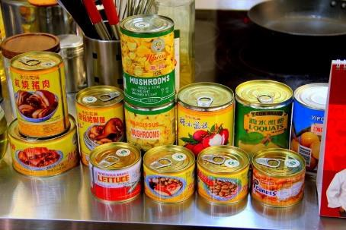Canned food – commonly fruit, vegetables, fish
For tours, due to the likelihood of breakage on rough roads, ‘jars’ of food are usually avoided.
- Convenience foods – these are pre-prepared food items manufactured by food suppliers and may include:
  - Sauce mixes
  - Boosters
  - Proprietary sauces
  - Energy bars
  - Biscuits
  - Dried pasta
- Long-life foods – such as milk
- Other dry goods – ‘dry’ goods are those that do not require refrigeration while sealed/unopened). They include powdered products, canned food, convenience food as well as:
  - Flour
  - Sugar
  - Nuts.

Beverages
The same principles mentioned above should apply to determining the beverages required for a tour:
- Glass is to avoided where ever possible – meaning there is a preference for canned product and plastic bottles
- Target planning needs to apply – in terms of product types, brand names and quantities.

Stow equipment, resources and supplies for transportation to camp site

Introduction
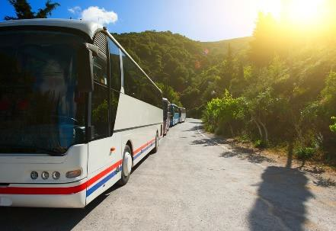An important part of the preparation for catering provision on a tour is the need to stow the identified resources and food ready for travel.
This section looks at factors inherent in this vital pre- departure stage.

Packing the gear

Transport options
The packing the gear for camp catering may require:
- Loading onto catering vehicles and/or trailers – purpose-built for the job
- Stowing items on board the tour coaches, 4WDs and other vehicles – as part of their other touring equipment.

Factors to consider
When loading/storing food and catering gear:
- Ensuring initial food safety of items prior to packing – this involves:
  - Checking ‘use by’ dates of food – these must not be exceeded for food safety reasons. Standard practice is to rotate stock in storage using the FIFO technique to avoid having to throw out out-of-date food
  - Making sure all packaging is intact and not broken/damaged – to help protect the integrity of the food
  - Verifying refrigerated and frozen food is at the correct temperature prior to loading – at or below 5⁰C for refrigerated food, and at or below -18⁰C for frozen food
- Stowing food to protect its integrity and safety during transportation – which may require:
  - Making sure all those who handle food have been suitable trained – in food safety and safe food handling techniques.
(Visit http://www.foodstandards.gov.au/publications/documents/complete_safefood.pdf
- ‘Safe Food Australia’ to see recognised food safety protocols)
  - Ensuring staff have washed their hands before they handle food – to help prevent cross-contamination
  - Loading food into clean and sanitised containers – to avoid cross-contamination
  - Using nominated refrigerated storage units for different items – such as separating meat from fish, storing vegetables in a different refrigerator to meats or keeping fruit in a different unit to other chilled foods.
Never store raw, uncooked meat or fish so it contacts cooked and/or ready to eat foods – in order to prevent cross-contamination.

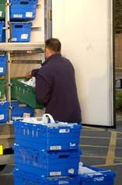Do not store raw, uncooked meat or fish above cooked and/or ready to eat foods – again, in order to prevent cross- contamination.
Local legislation may require all commercial businesses to transport food in a dedicated ‘food transport vehicle’ which complies with in-country food safety legislation.
  - Pre-chilling freezers and refrigerator units – so frozen and cold foods are placed into cold units at the required temperatures
  - Storing any pre-prepared hot food at or above 60⁰C – to maintain food safety.
  - It is not common to take hot, prepared food on tour but can occur where a tour departs in the afternoon and the food is to be used for the evening meal that night.
  - Using food thermometers to check temperatures – as opposed to guessing and/or assuming correct temperatures
  - Never storing any food directly on the floor – it must be (for example) wrapped, or in a box or refrigeration/food storage unit
  - Discarding food that fails to comply with applicable food safety protocols – rather than using/taking and risking food poisoning of tour group members
  - Separating foodstuffs from contaminants – so that detergents, cleaning agents and fuel for vehicles and cooking equipment are separated (preferably in a different vehicle) from the food to avoid contamination as well as flavour and odour taint
  - Protecting all unpacked food – for example this means covering fruit and vegetables (perhaps by placing them in a sealed carton) to protect them from contamination
  - Verifying the vehicle/s to be used for food transport have been properly serviced and maintained – to minimise the potential for breakdown which may jeopardise food safety by causing food to stay too long under ‘temporary’ (in transit) storage conditions.
- Using checklists to ensure all items are packed – these checklists may be:
  - Developed as part of the process of identifying food and resource requirements – as described in section1.4
  - Standard ‘loading sheets’ used to guide the loading of standard gear for standard tours/camps
- Stowing in the correct order – for example:
  - Loading catering gear (equipment and utensils) first
  - Loading food items lass – as late as practicable prior to departure as opposed to the day before or days before
  - Stowing items in accordance with projected usage needs while on tour – so catering staff can readily access the items they need in the sequence they will need them.
  - Items needs first are traditionally packed and loaded, last.

- Taking action to aid identification of contents of storage units and boxes – this may be done by:
  - Fixing a list to the outside of the container – indicating what is inside
  - Developing a control list/document – which is used as a central database for identifying the contents of individual containers
  - Using see-through containers
- Taking action to minimise foreseeable problems – such as:
  - Double-packing liquids – in an effort to contain leaks if the container is cracked/broken
  - Using straps and restraints and padding to stop gear and boxes and items moving about during travel – to help reduce damage caused by constant rubbing
- Ensuring the physical security of equipment and supplies – which can be done by:
  - Making sure doors to food vehicles/food storage compartments are closed and locked
– to prevent loss/theft and avoid contamination from various external sources
  - Never leaving food/catering vehicles or containers unattended
  - Stowing gear and dry food in built-in compartments in the vehicle/s, if available
- Noting (as part of the loading process) supplies and equipment that need to be obtained – with a view to:
  - Replacing food which has to be discarded to maintain the safety of the food that is loaded
  - Topping up items which are needed but have been short-supplied – and will need to be supplemented as the tour proceeds
  - Obtaining replacement equipment and utensils for items identified as damaged or unserviceable as part of the loading process.

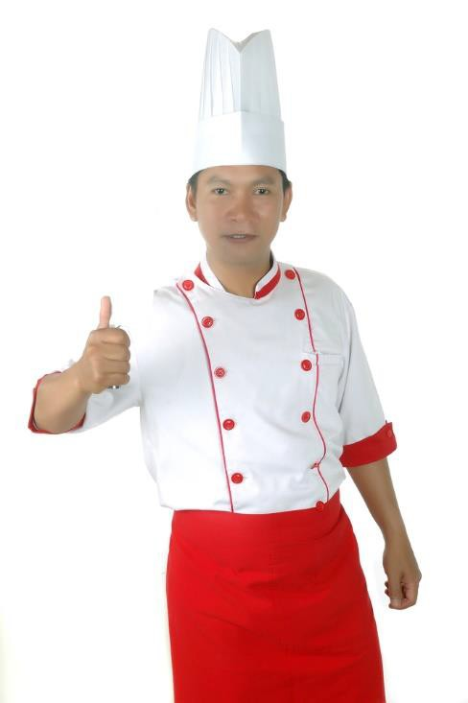

Work Projects
It is a requirement of this Unit you complete Work Projects as advised by your Trainer. You must submit documentation, suitable evidence or other relevant proof of completion of the project to your Trainer by the agreed date.

Note: this Work Project forms the basis for following Work Projects
To fulfil the requirements of the Work Projects for this Unit you are required to identify a tour operator to be approved by your Trainer/Assessor and provide actual or simulated camp site for that organisation.

  - To fulfil the requirements of this Work Project you are required to determine the camp site catering needs for a multi-day tour providing evidence you have:

    - Identified tour group requirements
    - Developed menus for the tour itinerary
    - Verified planned menus with management or tour group members
    - Identified equipment and resources required to support menus
    - Stowed equipment, resources and supplies for transportation to camp site.

Summary
Determine camp site catering needs

When determining camp site catering needs:
- Identify type and nature of the tour
- Identify tour routes, destinations and duration
- Determine tour group numbers and profile/s
- Decide service styles and meals required
- Identify advertised and/or contracted inclusions
- Liaise with relevant others to determine special needs
- Identify catering crew available/to be provided
- Consider weather and environmental conditions
- Find out budget for the catering
- Plan menus and menu items
- Address food and beverages
- Match menus/food to identified needs of the tour, group, activities, destinations and local availability of ingredients and resources
- Confirm menus with management and tour group members as required
- Base planning for scheduled tours on previous action taken and feedback regarding same
- Treat every custom tour as a unique catering event
- Identify the equipment and resources required to provide the planned/required food and beverages
- Load and stow equipment and supplies for the tour/camp site catering using Loading Sheets.

Element 2:
Prepare the catering area

Establish the catering area

Introduction
On arrival at the camp site one of the first steps is to establish the catering area. This section describes activities involved in this process.

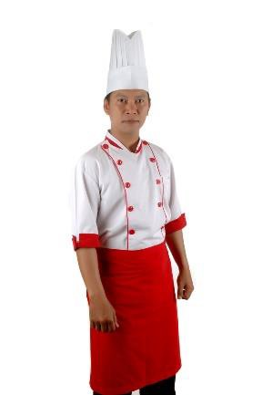Context
‘Establishing the catering’ has two possible meanings:
- Determining where the catering area will be (as distinct from other camp areas such as food service area, sleeping/tent areas, activity areas, latrines) in a free/public area, and setting up the catering (food production and dining) facilities
- Setting up the catering area within an existing building or area designated by the camp site management/owner.

Activities and considerations involved
When establishing the catering area there is a need to:
- Determine the layout for all the individual areas and items which comprise total catering provision.
This means considering the relative location (that is, the relationship to one another) of the following:
  - Food and beverage storage – dry, frozen and refrigerated
  - Preparation areas and surfaces including food washing
  - Food and beverage service areas and equipment
  - Clean-up facilities – for dishwashing, pot washing and cleaning glassware
  - Rubbish.
Factors to take into account are:
    - Logical flow – to save unnecessary walking between points
    - Security – to protect items from theft/unauthorised use
    - Previous work layouts for similar tours
    - Built-in facilities which need to be used and cannot be moved.
- Assemble equipment – which has had to be dismantled for the purpose of transportation
- Position equipment and items – see section 2.4

- Connect power sources – this can require:
  - Positioning, filling and running the generators – and hooking equipment up to them
  - Plugging electrical leads into power points where provided at camp sites
  - Using RCDs, extension leads and power boards
  - Connecting units to provided gas cylinders/tanks in established camp sites – or attaching equipment to portable gas bottles/cylinders.
  - When connected, gas-powered equipment must not only be checked ‘operationally’ but gas leads/lines must also be checked for leaks.
- Test equipment – as soon as all equipment has been assembled and/or positioned it must be tested.
This is important to give maximum notice of malfunctions so repairs can be made or alternatives obtained or worked out.
Testing needs to be ‘operational’ testing meaning it has to address the operational elements of each item as it will actually be used, not just whether or not it ‘turns on and off’.
- Stow supplies on-site – which involves:
  - Re-locating required food from tour/catering vehicles to catering area – it is often necessary to move all the food (given the way items are packed) but attention should be paid to only re-locating what is needed for the service sessions to be provided at the camp.
There is no point moving food simply for the sake of moving it.
- Ensure safe food handling conditions – which will involve:
  - Running any refrigeration units provided on-site as soon as the catering crew arrives if it is not already turned on – to pre-chill them
  - Using a food thermometer to:
    - Determine the temperature of operating/in situ units – to identify if they are acceptable or need to be adjusted
    - Monitor temperatures on an ongoing basis – so they can be recorded on documentation which is part of the food safety plan for the business
  - Making sure it is just the catering crew who handle/store the food
  - Checking integrity of food which is delivered to the camp by third party providers
  - Making sure places where food is stored is protected – from:
    - Pest, animal and rodent infestation and contamination
    - Airborne and dust contamination
    - Chemical contamination
    - Unauthorised human interference

- Clean and sanitise equipment and facilities – this:
  - May be required by the FSP for the operation
  - Should occur for all equipment and utensils which have been transported to the camp
– as these items can/will get dirty/contaminated during the transportation stage
  - Should occur for all equipment and utensils provided at an established camp/catering site or area – meaning it can never be assumed the items provided will automatically be clean and/or fit to use from a food safety perspective
  - Requires protecting food from contamination by the cleaning process
  - Storing cleaning agents after use separately from the food
  - Washing hands after cleaning and before handling food.



Store food and beverages

Introduction
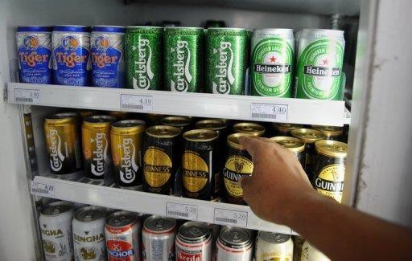The storage of food and beverages is an important consideration when providing camp site catering from security and food safety perspectives.
This section indicates protocols which should be employed to ensure safe and secure storage.

Security protocols
It should be standard practice to:
- Keep all food and beverages in areas which can be observed and monitored – so potential theft or unauthorised access can be identified
- Keep food and beverages in containers which are kept closed and/or locked – as opposed to allowing individual items to lie around
- Have someone in attendance in the catering area at all times – to deter theft/ unauthorised use
- Keep doors (where provided) to catering areas closed – and locked
- Make everyone aware stock is being monitored/counted – by telling them and/or making security protocols ‘obvious’
- Returning items to their assigned storage area once they have been used.

Generic requirements
Generic safe food handling protocols in relation to food storage are:
- Use food grade materials to store food that is susceptible to contamination – such as stainless steel
- Cover food in storage – to protect it from contamination
- Rotate stock to ensure it is used in the correct sequence – the method used for most food is FIFO: any food that exceeds its use-by date must be thrown out
- Keep all storage areas and equipment clean – meaning ‘free from visible contamination and odour’
- Never store food (including packaged food) directly on the floor or the ground – always put food on tables or shelving
- Supporting food safety records must be completed – to provide evidence required checks have been conducted, and to record temperatures of refrigerated and freezer units
- Conduct regular visual checks/inspections of food storage areas and the food itself
- Locate food to facilitate its retrieval in accordance with menu planning/intended use of items
- Requirements relating to observation of the ‘Temperature Danger Zone’ and the ‘2/4 Rule’ (see below) must be observed and implemented.

Temperature Danger Zone
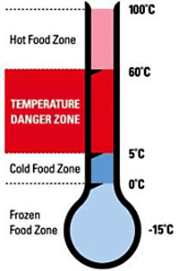The Temperature Danger Zone is the temperature range in which bacteria multiply most rapidly.
The range is 5ºC - 60ºC.
Every effort must be made to keep potentially hazardous (‘high risk’ – see below) food out of this temperature range.
Where food has to be in this range (such as when it is being prepared), the amount of time that food spends in this zone must be minimised.
It is important to note that all time food spends in the Temperature Danger Zone is cumulative. If a piece of meat is left out on a preparation surface for 1 hour, refrigerated and then brought back out into the catering/food preparation area, the time it then spends in the Temperature Danger Zone is added to the previous time – the clock (and the bacteria count) does not get reset to zero when the food was put in the fridge again.

The 2/4 Rule
Awareness of the 2/4 rule is critical in applying safe food handling procedures. The 2/4 rule states:
- High risk foods (see below) that have been in the Temperature Danger Zone for 4 hours (or more) must be discarded/thrown out
- High risk foods that have been in the Temperature Danger Zone for 2 hours can be refrigerated and then returned to the Temperature Danger Zone for another 2 hours, maximum
- When high risk food has been in the Temperature Danger Zone for 2 hours it must be cooked or eaten within the next 2 hours or thrown out.
There are no exceptions to this rule.

Dry goods storage
The dry goods store is a non-refrigerated store/area where canned and dried food is kept. Requirements include
- The area is fly- and vermin-proof as best as can be achieved – to minimise contamination by pests
- For night-time use make sure the area is well lit – to allow staff to see what they are doing and identify and remedy spillages
- Food storage containers are cleaned and sanitised before being re-used/re-filled – rather than being re-filled without cleaning in between uses, and as opposed to continually topping up the contents
- Any canned/tinned food must be transferred to an appropriate container and refrigerated once the container has been opened – it is not acceptable (for example) to open a can, use half of the contents and then return the open can to dry storage.

The food must completely used or be transferred to a plastic or stainless steel (or other appropriate) container and then placed under refrigeration.
If this cannot be done, the left-over food must be thrown out.

Refrigerated goods store
Refrigerated storage is used for fruit and vegetables, dairy products and meat.
Refrigerated storage may occur in transportable cool rooms or a variety of standing and portable units.
Requirements are:
- 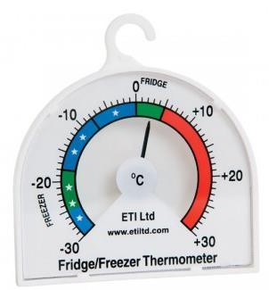The temperature is kept between 0°C - 4°C and this temperature is checked with an independent calibrated food thermometer – checks must be done at least once per day.
A calibrated thermometer is one which has been tested and proved to be accurate to within+/-1°C.
High risk foods (see below) should be able to be stored at 5°C for 7 days. They should be eaten within this time or discarded. Where the temperature is 3°C or less, this time could extend beyond 7 days.
- The cool room/refrigerator door is closed between uses and an effort made to minimise opening frequency – an open door raises the temperature and makes the unit more expensive to operate
- Hot food placed into refrigeration is broken down into small units – to enable faster cooling.
Where large units of food are placed in the refrigerator it takes a lot longer for the core of that food to move out of the Temperature Danger Zone.
Hot foods should be allowed to cool (perhaps by placing the food in pots into tubs full of cold water) before being placed under refrigeration: frequent stirring of the item will help it to cool quicker.
The ‘Two-step rule’ for cooling hot foods must be complied with (see below).
Some food safety plans prohibit the saving/refrigeration of cooked/hot food to avoid potential food safety problems in this regard.
- The cool room/refrigeration unit is not overcrowded – in order to enable air to circulate freely around food items
- All food is covered and protected from contamination – plastic film with a label attached to identify the food is common
- Potentially hazardous/high risk raw food is separated from cooked and/or ready-to-eat foods – this is to prevent cross contamination.
Never store potentially hazardous/high risk raw food above cooked and/or ready-to-eat foods as there is the potential for raw blood or juice to drip down onto the food below.

High risk foods
High risk foods (also known as ‘potentially hazardous’ foods) are those which are high in protein, such as:
- 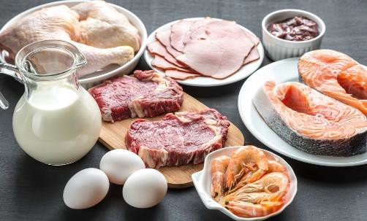Milk and milk products – butter, yoghurt, custards, cream cakes, cheese, baked custard tarts and dips
- Eggs and egg products – quiche, fresh pasta, duck and game bird eggs
- Meat and poultry – all types and all cuts
- Smallgoods products – ham, pressed chicken, but note salami is not a high risk food
- Processed meat products including chicken – pate, meat pies, sausages, sausage rolls, rissoles, meat balls
- Fish, shellfish, fish products, fish soups and fish stocks – caviar, fish balls, patties, salads, sauces and stews
- Prepared food, meals, sandwiches, salads and rice.

Two-step rule for cooling hot food
The two-step rule provides direction for the cooling of high risk hot food. It states:
- Step 1: Cool hot food down from 60°C to 21°C within 2 hours of removing the food from the stove, oven or other cooking unit.
- Step 2: Once the food has reached 21°C it should be placed into a refrigerator/cool room, and then cooled to 5°C (or below) within a further 4 hours.
If the cooling of high risk food does not meet these criteria, the food must be thrown out. In addition, note that once the food has reached 5°C, it can safely be put in the freezer.

Frozen storage
Freezers are used to store frozen produce.
Freezers may be chest type, up-right, or walk-in, but they must be maintained such that the food remains hard frozen (recommended at least -18°C).
Requirements for use of freezers include:
- Hot food is never frozen – cool it first following the two-step rule for cooling hot food
- Items that have been thawed are never refrozen
- Freezer doors are kept closed when the freezer is not in use
- Freezer temperature is be checked at least daily to ensure correct operating temperature
- Manufacturer’s instructions regarding the storage of frozen food products are followed – these may relate to storage temperatures and the length of time the product can be stored (for quality and/or safety reasons).

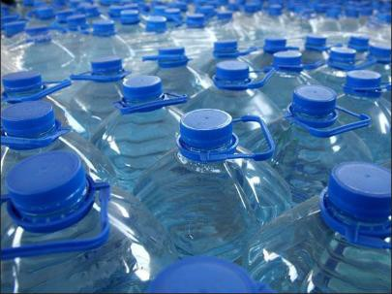Establish safe water supply Introduction
Catering crews may have responsibility for making sure the water they use for preparing food is safe and tour group members are provided with safe drinking water.
This section explains why this is necessary, describes how a safe water supply can be achieved and highlights the need to communicate water status to tour group members.

Need to guarantee safe water
It is vital for the catering crew to provide safe water to:
- Discharge Duty of Care responsibilities
- Maintain the reputation of the tour company
- Avoid being sued for negligence or similar
- Make sure tour group members do not become ill or die through drinking contaminated water
- Meet customer expectations
- Enhance tour group member enjoyment of the tour.

Important points
Important points to note are:
- Water that is safe to drink is also called ‘potable water’
- Just because water looks clean/clear does not necessarily mean it is safe to drink
- Just because water comes direct from a natural source (river or lake) does not necessarily mean it is safe to drink
- All suspect water to be used for drinking and cooking should be purified before use
- Water may be contaminated by physical contaminants, bacteria, viruses, parasites and chemical pollutants
- Local ice is probably made from local water.

Ways to create a safe water supply
There are a variety of ways to create safe drinking water.
As a standard rule, always adhere to the SOPs developed by the organisation to be used on the tour which is being catered for – different tour operators have different protocols and some destinations may be the focus of practices unique to their location.
This said, water may be purified by:
- Bringing the water to a rolling boil and boiling for five minutes, scoop any scum/detritus off the top – allow to cool, as necessary, prior to use

- Using water purification tablets – such as iodine, chlorine or halazone and following instructions provided regarding:
  - 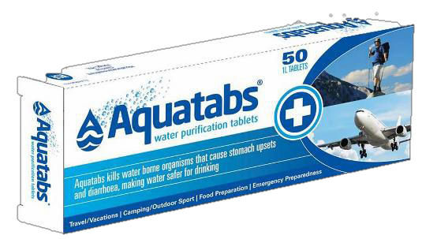Method
  - Number of tablets to the amount of water
  - Adding chlorine drops or liquid iodine – following manufacturer instructions
  - Using a commercial water purification system – featuring a combination of activated charcoal filtering plus a chemical (such as iodine).

Important note
Where the water at a camp site cannot be tested or cannot be made safe to drink:
- It must not be used for drinking or cooking
- Sealed bottles of brand name water should be used and issued to tour group members
- Time at the camp site should be avoided altogether or minimised
- Tour group members should be advised not to use it for bathing/washing.

Websites
Further information is available at: http://www.princeton.edu/~oa/manual/water.shtml - A guide to water purification
http://www.instructables.com/id/How-To-Purify-Water-Using-Iodine-Tincture/ - How to purify water using iodine tincture
http://en.wikipedia.org/wiki/Portable_water_purification - Portable water purification http://www.wikihow.com/Purify-Water - How to purify water (Five ways)
http://www.traveldoctor.com.au/Page/Knowledge-Hub/Travel-health-fact-sheets/Eating-and- drinking-safely - Eating and drinking safely

Communicating water status
The status of camp water should be communicated to tour group members.
This may be done by the catering crew, or the person in charge of catering may share details with the Tour Leader who then passes the information on to the group.
Topics to discuss/communicate are:
- Identification of water sources – which:
  - Are safe and can be used
  - Are not safe and must not be used

- Water safety issues – in relation to:
  - Whether or not tap water, where available, is fit to drink – and/or bathe in
  - Whether or not pump or well water, where available, is fit to drink – and/or bathe in
  - How to treat the water to make it safe – including:
    - Demonstrations of how to do this
    - Distribution of required equipment and/or materials
- Supply of water – and details regarding, as appropriate:
  - Need to conserve water and limits its use
  - Free/unrestricted supply
  - Any cost associated with accessing water
  - Prohibited/private sources which cannot be used by the tour group.

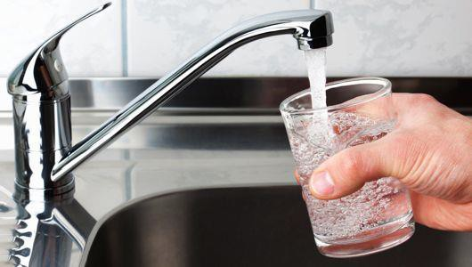

Position catering and dining equipment

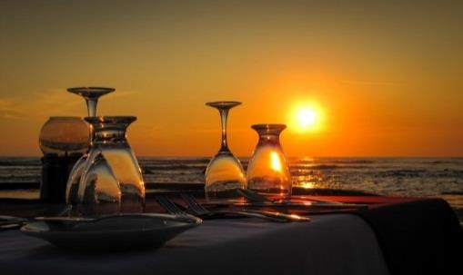Introduction
When the catering area has been established or determined, the requisite equipment must be ‘bumped in’.
This section addresses considerations when positioning catering and dining equipment.

Background information
It is useful to remember:
- ‘Bump in’ means to carry in, assemble and/or position equipment – to take items from the tour and/or catering vehicles and put them where required
- ‘Bump out’ means taking the items out of the area – and disassembling and/or re-loading them back on to the vehicles for transportation
- All this work needs to be completed well in advance of scheduled dining sessions – because food preparation and production still needs to occur before service can take place
- There may be local ‘regulations’ which need to be complied with – such as:
  - Where certain items – especially cooking equipment, generators and open fires – can be located
  - Use that can and cannot be made of installed/provided equipment
  - Safety requirements regarding operation of equipment
  - Times at which items/areas can and cannot be used.

Positioning catering equipment
When positioning catering equipment for camp site catering:
- Work quickly – time is important.
Time lost at this stage can often not be recovered/made up at a later stage.
- Adhere to (and or adapt as necessary) any pre-prepared plans for catering areas/equipment – which may have:
  - Been prepared for previous similar tours
  - Been prepared for the same destination
  - Been prepared especially for this tour
- Place items to support the normal logical and smooth work flow typical of commercial kitchens/venues – that is:
  - Storage to preparation
  - Preparation to production
  - Production to service

- 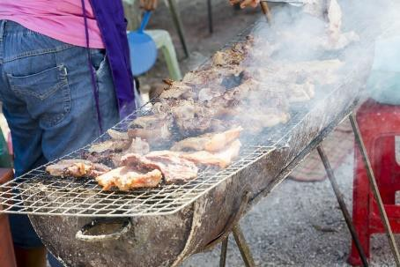Physically situate individual items so there is operational efficiency – in terms of, for example:
  - Providing sufficient working space to enable safe movement when handling heavy objects, hot items, carrying wide containers with food on them, and allowing others to perform their work without interruption
  - Locating individual items correctly – so, if possible:
    - One item does not obstruct/block another
    - Opening one item does not impede access to another
    - Cooking equipment is not placed on top of other equipment
    - They do not protrude and present an injury risk
- Make sure items are stable and level – and they do not:
  - Wobble
  - Over-hang an edge
  - Risk tipping up/over
  - Allow food/cooking oil or liquid to accumulate on one side/corner of an item or drip or spill
- Protect the equipment once it has been positioned – from:
  - Contamination – after they have been cleaned and positioned, to the best extent possible: using covers is effective.
  - Prevailing weather conditions.
- Prepare the items for use – in addition to testing (see section 2.1) and depending on the items and the menu items to be produced there may be an immediate need to:
  - Load fat into deep fat fryers – and heat to melt
  - Pre-heat ovens.

Positioning dining equipment
When positioning dining equipment for camp site catering:
- Locate the dining area in the best position – which should:
  - Take advantage of views available
  - Optimise natural/available shelter from the elements
  - Position it to facilitate the transport/service of food from the catering area – that is, as close as is practical to the kitchen area
- Establish the dining area – which may involve:
  - Using dining facilities provided on-site
  - Pitching dining tents or putting up marquees – if required
- Set sufficient tables and chairs – to accommodate known group members

- Align tables and set-ups with any table plans provided by the group – for custom tours which may specify:
  - Need for a head table
  - Number of tables
  - Number of seats at each table
- Set-up to support food service style to be provided – which may/may not require establishing:
  - Crockery station/pick-up point
  - Cutlery station
  - Food displays – for hot and/or cold food
- Set-up beverage service stations as required – which may require:
  - Setting/providing glassware and other beverage service accoutrements
  - Creating a service bar – and loading with stock
  - Positioning drink refrigeration.

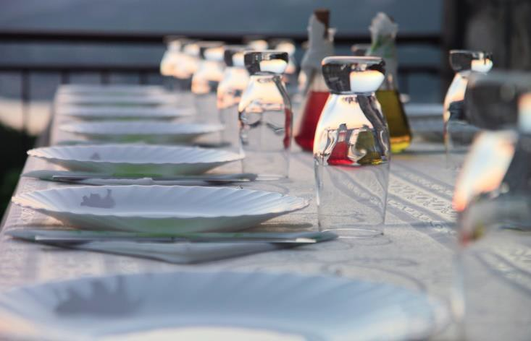

Position cooking and dining utensils and ancillary items

Introduction
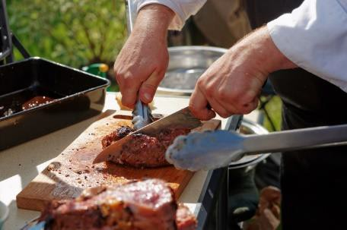When the food production and service areas have been established, the next step is to position the necessary utensils and items in those areas.
This section discusses factors to consider when doing this and identifies the articles which may need to be put in place.

Factors to consider
When locating cooking and dining utensils and ancillary items:
- Work quickly
- Handle items with care
- Observe safe food handing protocols – because these items will be used for food handling or service
- Check items as they are put in place – to:
  - Make sure they are clean – clean/sanitise items as necessary
  - Verify they are safe to use/suitable for use – that is, they have not been damaged during transport
- Follow planned set-up arrangements – such that:
  - Catering vehicles are positioned as close as possible to the areas – to:
    - Reduce walking/carrying required
    - Save time
  - Items are placed in the designated location – so that:
    - There is consistency across camp set-ups
    - All catering/tour staff know where things are
  - Items are located in the required sequence – first things first because:
    - Food preparation and production may depend on having certain items available/in place
    - Many placements are dependent on other items having been already put in place
- Do not put utensils and ancillary items on the ground – store them:
  - On portable racking
  - On tables
  - On mobile shelving
  - On built-in shelves and facilities available on-site
  - In the planned/designated location or space.

Cooking utensils and ancillary items

Context
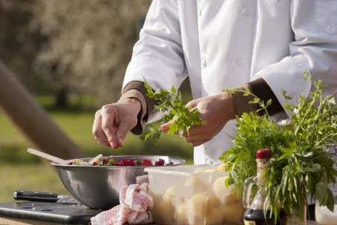It is possible the catering for a camp can cover a wide range of tour options in terms of:
- Small groups with simple catering requirements – based on producing small amounts of food using items such as portable stoves with camp stoves (and perhaps a reflector oven), a small range of pots and pans to fry, grill and re-heat basic menu items such as grilled meat, pan-fried fish and reconstituted convenience food
- Medium to large groups requiring sophisticated menu items and service – essentially reproducing the same standard and quantities of catering generated out of a kitchen and provided from a restaurant at a three-star plus venue.
This means there is a potentially large range of utensils and ancillary items that can be required.

Classifying equipment
The equipment must reflect the menu items to be prepared, produced and served.
All the required items need to be positioned, and there is no need or time to position items which are not needed for this camp/service session.
Because there is such a large range of equipment and utensils available it is useful to group them into three categories: utensils, mechanical equipment and large (fixed) equipment.
It is possible, depending on the size of the tour group, their requirements and the menus which have been developed for service, any or all of the following could be required.

Utensils
Utensils are small hand-operated pieces of equipment such as:
- A range of knives (or knife kits) – such as:
  - Chef’s knife – used for chopping, slicing and dicing
  - Utility knife – used for salad and vegetable preparation
  - Paring knife – used for trimming and paring fruit and vegetables
  - Boning knife – used for boning out joints
  - Slicing knife – used for carving and slicing cooked meats
  - Serrated knife – used to cut breads and cakes
  - Butcher’s knife – used for cutting, sectioning and trimming raw meat
  - Cleaver – used for chopping and splitting raw meat and vegetables
  - Palette knives – known as ‘spatulas’, these are used to lift, mix, spread and scrape soft mixtures
  - Steel – for sharpening knives
- Mouli – used to strain pips, skins etc from purees and other mixtures

- 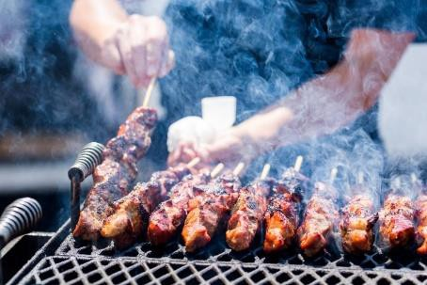Ladle – used to scoop foods and liquids from one container/pot to put into another container/bowl
- Chinois – a conical sieve
- Selection/range of bowls – for mixing and holding food
- Measuring bowls, cups, spoons and scales – for weighing ingredients
- Whisk – used to whisk/aerate a variety of ingredients in many recipes
- A range of pans – which might include:
  - Bain-marie – used to keep foods hot when on display and/or ready for service.
  - Braiser – used for browning, braising and stewing.
  - Double boiler – used to cook foods at low temperatures and not over direct heat
  - Inserts/hotel pans– used for baking, steaming and holding foods at service counters
  - Roasting pan – used to roast larger meat cuts
  - Sauce pot – used to cook soups, sauces and other liquids
  - Sauté pans (sauteuse and sautoir) – used to brown, sauté and fry food
  - Stock pot – used to cook stocks, soups and other large volumes of liquid
  - Wok – used for stir-frying
  - Frying pan – for basic pan frying
- Ricer – a piece of equipment (similar to an over-sized garlic press) used to make (for example) mashed potatoes
- Cutting boards – for chopping food
- Dutch ovens – a camp favourite which is expected by many tour groups: see more in section 3.2
- Skewers and sticks – these are another camp favourite used for cooking shashliks/kebabs over an open fire/on a grill plate
- Aluminium foil – popular for cooking food in the coals of a camp fire.

Mechanical equipment
Mechanical equipment can be large or small and is electrically operated and includes:
- Mixers – used for blending ingredients, liquidising foods and making sauces
- Slicers – necessary for slicing a variety of meats and other products
- Food processor – used for cutting and mixing food.

Large equipment
They can be electrically or gas operated and includes items such as:
- Stoves – for baking, roasting plus use of burners on top of the stove for heating, re- heating and other stove-top cooking such as sautéing, boiling
- Salamanders – used to heat and brown foods as well as to prepare dishes like crème brûlée where the top of the dish has to be caramelised

- 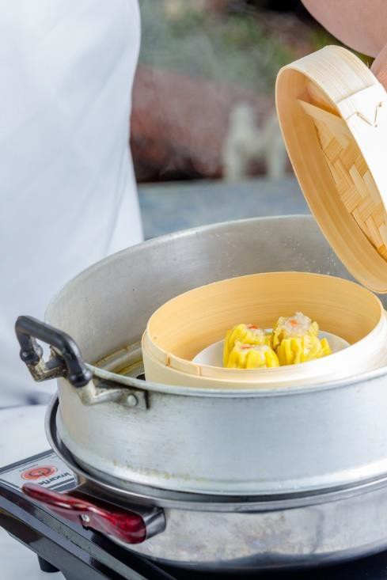Steamers – required for steaming foods such as fish, seafood, chicken and vegetables
- Bain maries – usually used to keep hot foods hot while on display/waiting for service
- Bowl cutter – used to chop/slice meat and to cut vegetables
- Mincer or grinder – used for mincing/grinding all types of meats and poultry
- Deep fryers – required for the cooking of a wide variety of dishes including battered fish and seafood, chips/French fries, fritters, onion rings, tempura vegetables
- Rotisserie – used for roasting (usually chickens)
- Brat pans – a deep, rectangular, large capacity (50
– 120 litres) cooking pot used to prepare stocks, sauces, soups and wet dishes: has a tilting mechanism so foods can be tipped out into storage, display or service containers.

Dining utensils and ancillary items

Once again, the dining utensils and ancillary items should reflect the prepared menus for the tour/camp and/or the specific service session being prepared for.
Items that may be required can include:
- Cutlery. at the cutlery stations – which may include knives (main and entree), forks (main and entree), spoons (tea, soup, dessert)
- Crockery, at crockery stations and food service points (for plating) – which may include main course plates, side plates, soup bowls, dessert bowls, cups and saucers, serving platters
- Glassware, at service points and bar set-ups – which may include a variety of types of glasses appropriate to the beverages being served (beer glasses, wine glasses, highballs, old fashioned plus others as needed), jugs for juice and water
- Single use items, at service points – these are items intended to be used once and then discarded, such as paper serviettes, drinking straws, stirrers, plastic/disposable cutlery, doilies
- Portion control packs for communal use, at service points – these are pre-packed items giving single serves of products such as condiments, proprietary sauces, sugar, sweetener, jams, tea and coffee, biscuits.

Work Projects
It is a requirement of this Unit you complete Work Projects as advised by your Trainer. You must submit documentation, suitable evidence or other relevant proof of completion of the project to your Trainer by the agreed date.

Note: this Work Project follows from Work Project 1.1

  - For the tour and camp site identified in Work Project 1.1 prepare the catering area providing evidence you have:

    - Established the catering area
    - Stored food and beverages
    - Established safe water supply
    - Positioned catering and dining equipment
    - Positioned cooking and dining utensils and ancillary items.

Summary
Prepare the catering area

When preparing the catering area:
- Define/determine and establish the physical area to be used as the catering area
- Assemble and position catering equipment
- Establish a logical flow for the storage, preparation, production and service of food
- Check, clean and/or otherwise ready facilities which may be provided on-site
- Store and ensure the security of food and beverages
- Establish and maintain safe food handling protocols
- Implement and monitor applicable food safety plan/program requirements
- Determine safety of and/or establish a safe water supply
- Inform tour group members regarding safety of local/available water
- Locate dining equipment and utensils to enable service of planned food/menus
- Check and clean/sanitise equipment and utensils as part of the preparation process.

Element 3: Produce food

Apply food preparation techniques

Introduction
A standard requirement in the production of food is the need to undertake the necessary food preparation techniques.
This section discusses mise en place and describes a range of food preparation techniques.

Standard requirement
All operators should make it a non-negotiable requirement that all camp staff involved in handling, preparing, producing and service food hold a current food handler qualification recognised by the host country food authority.
Mise en place
Selecting and assembling the equipment and utensils needed is part of the process known in catering/the kitchen as ‘mise en place’.
This is a French, culinary term meaning ‘to put in place’.
Mise en place applies to both ingredients and equipment needed for a dish and overall food preparation.
Mise en place is something to be done for every recipe, every time an item is produced.
Purpose and importance of mise en place
The purpose of mise en place is to get everything ready before cooking or food preparation begins so there is no need to interrupt or delay the process.
If the cooking/preparation process has to be interrupted there is a risk of:
- Producing a poor quality end product – because the required cooking/preparation procedure has not been followed
- Wasting food – because the poor quality product has to be discarded
- Lowering customer satisfaction levels – if they are served poor quality food
- Reducing the potential for repeat business – if tour group members are not happy with the food they have been served
- Slowing down the service of food to the group – and/or the production time of items.

Activities involved
Work involved in mise en place can involve:
- Obtaining the necessary items ready for use – that is, getting items from trucks/vehicles or the portable ‘store area’ and placing them in position ready to use
- Putting items together so they are ready to use – as many items need to be dismantled for cleaning, storage and/or transport so they need to be re-assembled for use
- Gathering together all the ingredients for the dish – so they are weighed, measured, checked and ready to use/prepare
- Unpacking and unwrapping food items – so they are ready to use
- Opening cartons, cans and packages – and other containers holding food needed for the menu item/s being prepared
- Washing and cleaning fruit and vegetables – see below
- Peeling and trimming items – see below
- Cutting food/ingredients as required – see below

Washing and cleaning fruit and vegetables
Standard practices when washing and cleaning may involve:
- Washing all vegetables thoroughly in cold water
- 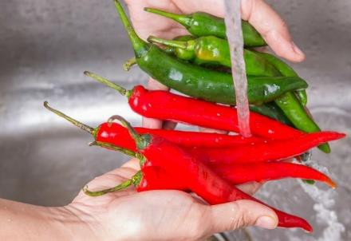Washing green leafy vegetables (for example, spinach, lettuce, silverbeet and kale) several times to make sure any insects and dirt clinging to the leaves are removed
- Scrubbing root vegetables which are not peeled, such as potatoes used for baking, with a stiff brush under running cold water
- Soaking vegetables like cauliflower and broccoli in salty water for 30 minutes to kill any insects present
- Giving extra attention to leeks which need special washing to remove dirt between the layers of the vegetable– after cutting leeks lengthwise, hold them under cold running water, separating the layers to remove the dirt
- Washing celery well – pay particular attention to the insides of the stalks which often need vigorous washing to remove clinging dirt.

Peeling and trimming fruit and vegetables
After the vegetables have been washed and cleaned thoroughly, many need to be peeled and trimmed.
A peeler, a chef’s knife or a paring knife may be used to remove skin, root ends and blemishes.

Peelings
These are the outside skins, tops and tails from fruit and vegetables. They usually have no culinary use and can be discarded.

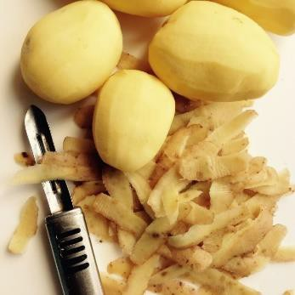Vegetables should be peeled or scraped thinly to remove only the skin, as most nutrients are just below the skin/surface.
Thin peeling also, naturally, minimises wastage.

Trimmings
Trimmings are the edible good quality off-cuts from fruit and vegetable preparation.
They should be saved for use in stocks, sauces, mirepoix and puree.
The flesh of some vegetables turns brown when exposed to air.
To prevent this happening the following procedures are recommended:
- Cover peeled potatoes in cold water until they are ready for use
- Jerusalem artichokes and eggplants can be placed in a mixture of cold water and acid, usually lemon juice or vinegar. For small quantities, the acid may be sprinkled directly onto the vegetables.
The peels of some vegetables – such as zucchini and squash – are edible and therefore the vegetables do not need peeling: just wash them thoroughly.

Cutting food/ingredients

Tips for safe use of knives

Cleaning
- Always wash and wipe the knife dry before use
- Never leave knives in a sink in water
- Dry thoroughly with the blade pointing away from the hand
- Place clean knives in a wrap protector and/or toolbox.

Handling knives
- Use correct knife for each activity
- Keep knives sharp
- Hold knife and item being cut firmly (but not too tight)
- Keep fingers away from the blade
- Cut away from (not towards) the body
- Do not immerse knives under water or leave them in food
- Clean and wipe the knife with the blade facing away
- Store knives safely after use
- Do not try and catch a falling knife
- Do not leave knives sitting on a bench or cutting board with the blade facing upward.

Cutting techniques
- 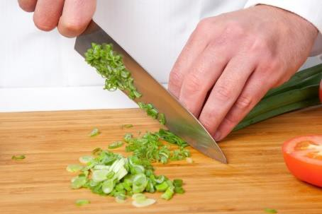Hold knife firmly by the handle with fingers together
- Fingers should grasp the food, be tucked in while the thumb sits behind the item being cut
- Only knuckles should be visible from above
- When cutting, use the knuckles as a guide for the knife
- Keep the point of the knife on the board
- Use the correct knife for the activity – make the effort to get the right knife, and to change knives between jobs as appropriate: it takes five seconds to change knives but hours to go to the doctor and get stitched up!
- Some operators require staff to use a protective glove on the non-cutting hand.

Cuts and shapes
The following table lists and describes the most common types of cuts used in basic preparation.

Method | Description | Examples of Use
Slice | Cutting a thin, broad, flat piece of food, usually by using a sawing action | Bread slices Onion rings
Chop | To cut food into uneven bits by using short, sharp blows (food may be chopped fine, medium or coarse) | Chopped parsley for salads and duxelles
Dice | Cutting into even cubes, which may be small, medium or large | Macedoine Brunoise
Shred | To cut into very fine, irregular strips | Lettuce, for use in salads  Cabbage, for use in coleslaw
Crush | To squash into fine, medium or coarse particles, often by using the side of the knife | Crushed garlic

Practical tips
Always wash vegetables prior to preparing them.

Chopping and dicing
For chopping and dicing, the tip of the knife is usually kept on the cutting board while the blade is raised and lowered rapidly with a forward up and down movement.
The cutting is done on the forward stroke.
Never lift the tip of the knife off the cutting board.

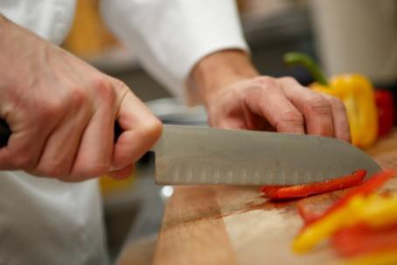Slicing and shredding
For slicing and shredding, the blade of the knife is passed across the item being cut with a smooth forward motion.
Again the cutting is done on the forward stroke.
For both cutting methods, the free hand is used to push the food towards the blade and/or regulate the size of the cut.

Slices
The following procedure is recommended for slicing an onion:
- Remove the top
- Peel the onion by slitting the outer skin and peeling it off
- Cut the onion in half vertically from the stem to the root
- Remove the root – this permits the slices of onion to fall apart
- Finely slice the onion by cutting with even strokes in the same direction as the poles (from root to stem)
The uses of sliced onion include making soups, sauces, stews, braises and vegetable dishes.

Coarse chopped
Coarse chopped cuts are ‘roughly’ cut vegetables.
That is, the size and shape do not need to be as precise or accurate as all other cuts because the vegetables are (usually) strained out of the product being produced and are not served to customers.
Cut size is commonly approximately 25 mm.
A ‘mirepoix’ is roughly chopped vegetables (carrot, celery and onion: thyme is added) used as basis for sauces and to improve flavour of cooked meats.
The size of the mirepoix (that is, the size of the pieces of vegetables) is determined by what it will be used for.
For example, the mirepoix for a fish stock would be smaller than the mirepoix for a beef stock because fish stock only takes 20 minutes to cook whereas beef stock takes 6 – 8 hours.

Mincing and dicing
Mincing means cutting into very small pieces
Dicing means cutting into slightly larger pieces (Macedoine and Brunoise are dice shape) The end use for the item will dictate whether it is minced or diced.

Dicing an onion
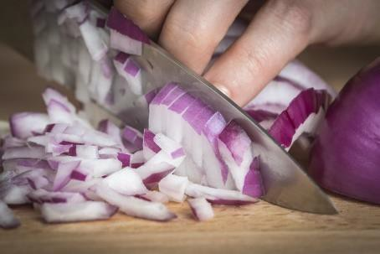Dicing an onion presents a special problem for cutting because it is layered rather than a solid piece. Practice dicing an onion as follows:
- Cut a peeled onion in halves from root to stem – do not remove the root
- Lay the cut surface on the cutting board and with the tip of the chef’s knife, cut each half lengthways at 2 mm intervals: do not cut through the root of the onion as this holds the slices together
- Next, make 2 – 4 horizontal cuts (depending on the size of the onion) at right angles to the other cuts. Now, the onion has been cut in two directions and the root end is still holding the pieces together
- Slice down through the onion at 2 mm intervals from top to bottom. The onion will fall onto the cutting board in small dice.
The piece left over containing the root is used in mirepoix or put into stocks.

Chiffonnade
This is a cut where the product (usually lettuce or cabbage) is cut into finely shredded strips.
See http://www.youtube.com/watch?v=aO-9VmnXHB8 (‘How to chiffonnade a lettuce’: 28 secs).

Julienne
These are strips of vegetables (such as carrots but can also be, for example, ham) that measure 2 mm x 2 mm x 40 mm long.

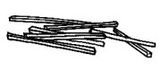
The procedure is:
- Top, tail and peel a carrot
- Cut the carrot into lengths of approximately 40 mm
- Square off the sides of each length
- Slice the carrot into thin strips 3 mm thick – take the thin strips, lay them flat on the cutting board, and using a chef’s knife, cut lengthwise to obtain smaller, thin matchstick strips.

Macedoine
These are vegetables cut into cubes.
They are bigger than Brunoise being 8 mm x 8 mm x 8 mm.


The procedure for preparing a Macedoine of apple is:
- Peel and core the apple and place it into acidulated water (water with added lemon juice) until ready for use – placing the apple into acidulated water prevents it from oxidising in the air and turning brown
- Stand the apple upright and square it off, then cut the apple into 8 mm thick slices – place the slices onto the cutting board and cut into 8 mm strips, then cut the strips into 8 mm cubes.

Bâtonnet
This is a baton cut of 6 mm x 6 mm x 45 mm. Potatoes and carrots are often cut this way. Jardinière
These are small batons of vegetables, similar to Julienne but bigger being 4 mm x 4 mm x 20 mm.

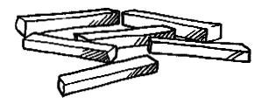

Paysanne/fermière
These are thinly sliced triangular, round or square shapes.


The round shapes must be 15 mm in diameter, and the squares and triangles must have 5 to 10 mm thickness.

Lozenge
A thin diamond-shape cut about 6 mm thick.
See http://www.youtube.com/watch?v=ur85o7hgvyQ (‘How to cut a lozenge from a carrot’: 3 mins 20 secs).

Brunoise
These are small cubes measuring 2 mm x 2 mm x 2 mm.


The procedure is:
- Cut into julienne – the first step of cutting into brunoise is to cut into julienne
- Stack the julienne strips into piles and then cut through the pile of julienne strips at 3 mm spaces to produce the brunoise cubes – using this technique is much quicker than cutting one strip at a time.

Rondelle
These are round cuts (like a coin) of, for example, a carrot.
The rounds can be of different thicknesses for different uses – thinner cuts for salads, thicker cuts for use as a vegetable to accompany a meal.

Oblique/roll cut
A cut where the sides of the carrot are not parallel to each other
This cut requires rolling the carrot between cuts to obtain this unique shape and unusual shape.
See http://www.youtube.com/watch?v=jShrXQInpek (‘How to oblique cut on vegetable’).

Online videos
See more at:
http://www.youtube.com/watch?v=cV0c7qiNjuI (‘Basic knife skills 1 of 2’: 8 mins)
http://www.youtube.com/watch?v=WSTBJ82nUts (‘Basic knife skills 2 of 2’: 7 mins 34 secs)
http://www.youtube.com/watch?v=wvy_sUJKJ1U (‘Classic Carrot Cuts - Rondelle, Demilune, Paysanne’: I min 49 secs)
http://www.youtube.com/watch?v=FpSEs_hEBG4 (‘Chef Kyle - Carrot/rondelle cut’: 2 mins 45 secs)
http://www.youtube.com/watch?v=dtBssdM2nTU (‘How to Brunoise’: 28 secs)
http://www.youtube.com/watch?v=ML5flgorZYc (‘How to Dice, Julienne, Brunoise and Bâtonnet’: 2 mins 57 secs).

Turned vegetables
Turning is the process where root vegetables (commonly potatoes and carrots are turned) of different sizes are shaped (or ‘turned’) into the same size and shape.

This results in even cooking and enhanced presentation/eye appeal.

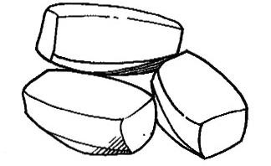
The best knife to use for turning vegetables is a turning knife but a standard paring knife is also suitable.
The vegetable to be turned is first cut to the required size and then held in one hand: the knife is used in the other.
There is a knack to turning vegetables into regular-shaped barrels – one way to learn the even wrist action required for turning is to practice on a hard-boiled egg (shell on): hold the egg lengthways between finger and thumb and scrape the blade lightly down the shell until comfortable with the even flow of the knife.
An exception is turned mushrooms. A series of grooves are scored in a mushroom cap, at an angle of approximately 25°, removing the skin at the same time.

Turning a potato
The procedure for turning a potato is:
- Peel the potato with a peeler, wash and place it in cold water – peeled potatoes are kept in cold water to prevent them from oxidising in the air and turning brown.
- Cut the ends off the potato squarely, then take the potato in one hand and with a slight curving action, slice the potato from top to bottom
- Rotate the potato slightly and repeat the action and continue to do so until a barrel-shape with six to eight even smooth sides is obtained.

Turning a carrot
- Peel the carrots and cut them into lengths
- Cut very large carrots into halves or quarters
- Turn each piece into even-sized barrels.

Chopping parsley
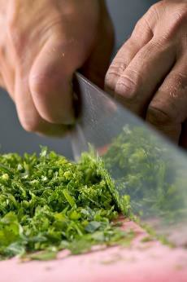The following procedure is recommended:
- Separate parsley from stem
- Wash the parsley in a bowl of cold water
- Remove the stalks and finely chop the parsley with a chef’s knife
- Place in a clean cloth, fold over and wash under cold running water and squeeze out the surplus water so the parsley is dry and loose.

Peeling a tomato
The only way to peel a tomato without damaging its flesh is by dropping it into boiling water first.
The following procedure is recommended:
- Wash the tomato and, with the tip of a paring knife, cut a small cross in the bottom
- Remove the eye of the tomato, that is, the stem end
- Drop the tomato into rapidly boiling water for 10 – 15 seconds
- Plunge it quickly into iced water
- The skin will now be split and easy to remove.
If some of the flesh comes away with the skin, it means the tomato has been left in the boiling water for too long.
The uses of diced onion include compound butters, sauces, duxelles and cooked tomato concasse

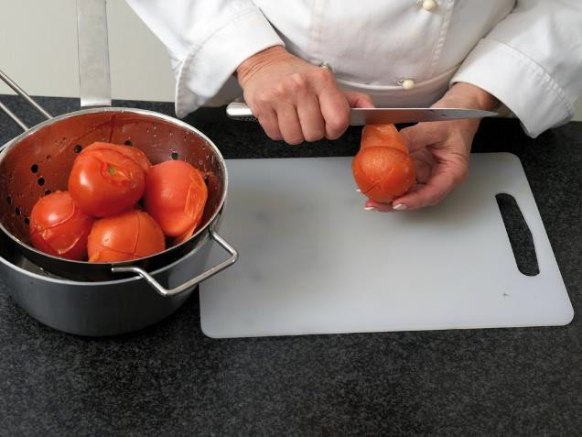

Preparing citrus fruit
Lemons, oranges and grapefruits are frequently used for garnishing and can be cut into a variety of shapes.
The three common cuts are slices, wedges and segments.

Peeled slices
- Remove both ends of the fruit to just expose the flesh
- Stand the fruit on a cutting board and with a sharp knife and using a slightly curved action, slice off the skin and the pith without cutting too much into the flesh. After the first slice, follow the line of the exposed flesh
- Turn the fruit on its side and cut slices 3 mm thick and remove any pips.

Wedges
- Remove both ends of the fruit without cutting into the flesh
- Stand the fruit on a cutting board and cut in half. Then cut each half into four to six wedges, depending on the size of the fruit
- 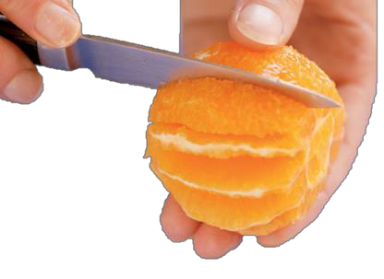Remove any pips and cut off the strip of pith from the centre of each wedge.

Segments
- Cut off the ends of the fruit squarely so as to just expose the flesh
- Stand the fruit on a cutting board and with a sharp knife and using a slightly curved action, slice downwards
following the shape of the fruit to remove all the peel and pith and as little of the flesh as possible
- Hold the fruit in one hand and, working over a basin, remove each segment by cutting along each side of it close to the membrane
- Squeeze the juice from the core into the bowl.

Peeling and crushing garlic
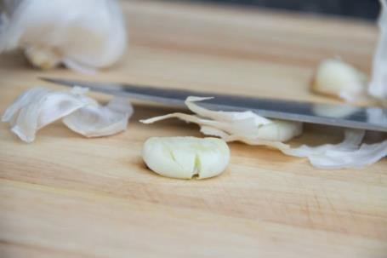Garlic has a very strong aroma which can taint other food, so crushing garlic should be one of the last tasks in mise en place preparation.
- Peel the garlic clove by placing it on the cutting board and pressing it firmly with the side of the knife blade
- The peel is now broken and the clove can be easily removed
- Using a chef’s knife, finely chop the garlic and then add salt in the ratio of a quarter part salt to one clove of garlic
- With the flat of the knife blade, grind the garlic and salt mixture to form a paste
- The garlic is then submerged in oil for storage.
After crushing garlic, always wash the cutting board in hot, soapy water to remove all traces of the garlic aroma.

Use a chopping board
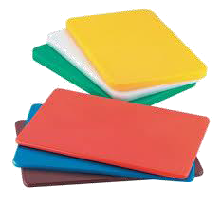Cut food on the appropriate chopping board.
The following gives an indication of the common uses and colours:
- White – for dairy products and bakery items only
- Red – for raw meat only
- Blue – for seafood only
- Yellow – for poultry only
- Brown – for cooked meat only
- Green – for fruit and vegetables only.
Always change, wash and sanitise boards between uses.

Thawing food

Products which may need to be thawed
Foodstuffs which require defrosting include:
- Meats – all types and all cuts
- Fish – all types; whole fish and all cuts
- Seafood – such as prawns and scallops
- Vegetables
- Prepared food – such as:
  - Bought-in, pre-prepared food – such as breaded prawns
  - Items prepared in-house and frozen for later use. Importance of thawing food products correctly Foods must be thawed correctly to:
- Reduce the potential for food poisoning – if improper defrosting techniques are used the thawing process may take too long raising the possibility of bacteria multiplying to unacceptable/dangerous levels
- Ensure the item is properly thawed before cooking or reheating – if items are not properly defrosted then the cooking process:
  - May not allow the food to be heated to the required temperature to ensure food safety
  - May not properly cook the item – meaning an unsatisfactory product (uncooked, unpalatable) is served to the customer.

Standard thawing practices
There are three ways to defrost frozen products:
- In a refrigerator/cool room – large pieces of meat may take 2 - 3 days to defrost so planning ahead is vital.
Thawing under refrigeration is the preferred method of thawing as the food is always out of Temperature Danger Zone (5⁰C to 60⁰C)

- 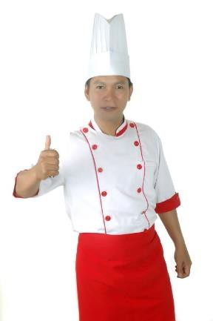If pressed for time a microwave can be used to defrost items – moving pieces of food during the procedure to ensure even defrosting and guard against cooking of items
- Run the item under cold water (less than 20°C) – this is not suitable for all frozen items.
For example, this option could not be used to thaw crumbed fish but it would be suitable for thawing fresh fish fillets.

Other points to note:
- It is not acceptable to thaw items out by placing them in a bowl or sink of water
- Only defrost the items and amounts required for use/service
- Never thaw products above cooked/ready-to-eat products – to guard against cross contamination
- All food should be cooked immediately after thawing.
- Discard all food that exceeds the 2/4 rule
- Throw out all food defrosted in an uncovered state – or which has defrosted in damaged packaging
- Discard all food which has been thawed and re-frozen.

Re-constituting items
It is essential to follow all manufacturer’s instructions regarding the reconstitution of dried and concentrated products.
Procedures may include:
- Measuring and adding other ingredients to the product – commonly required ingredients to be used as part of the reconstitution process (depending on the type of the ingredient/product) include:
  - Water
  - Cream
  - Milk
  - Stock
  - Seasonings
- Soaking – there can often be a requirement to pour dried ingredients and add liquid to soak and re-hydrate the ingredient prior to further processing
- Simmering – some ingredients:
  - May need to be soaked for a nominated amount of time before being simmered
  - Can have water added and be simmered straight away.
- A mix of actions such as:
  - Adding nominated liquid in specified quantities
  - Blending ingredients

- Applying heat in a specified manner (in a pot/saucepan, in the microwave) and cooking for a given time
- Adjusting flavour of the product – which may require:
  - 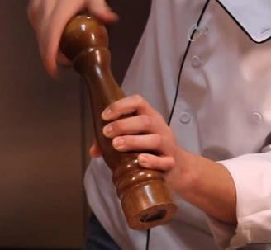Addition of salt and pepper
  - Inclusion of herbs and spices
  - Addition of lemon juice or vinegar
  - Addition of condiments of any sort
  - Addition of sweetening agent (such as sugar or honey)
- Adding garnishes – to the finished/reconstituted product to enhance presentation.

Preparing a bar for service
Preparing a bar/beverage service point for service may include:
- Stocking bar products and materials in accordance with enterprise requirements – including :
  - Beverages – hot, cold, alcoholic and non-alcoholic as planned/required
  - Glassware and service gear
  - Ice
  - Straws
  - Tongs and service spoons
- Ensuring service equipment is ready for use – meaning items are:
  - Clean
  - Operational
  - Sufficient in number
- Storing items in the correct place at the correct temperature – so that:
  - Cold drinks are served cold
  - Hot drinks are hot
- Setting up the bar and service area – ready for:
  - Staff to serve and prepare drinks
  - Customers to use – as in:
    - Self service
    - Open bar – where all drinks are free
    - Paid service – where guests pay for drinks they order
- Setting out lists – to:
  - Advise what is available
  - Indicate prices, if applicable.

Apply food production techniques

Introduction
When food/ingredients have been properly prepared the menu items need to be produced in accordance with target quantities and other requirements.
This section explains a range of basic food preparation techniques and presents standard practices which must be observed.

Recipes
This unit does not provide examples of recipes for camp catering because:
- Standard recipe requirements will vary between tour operators
- Catering teams have their own sets of standard recipes
- Ingredients vary enormously between different locations
- Tour types and individual tour needs often dictate the menu items to be prepared
- Budgets will dictate the raw ingredients which can be used.

Basic food production techniques
When providing camp site catering it is possible a range of cooking/food production techniques will need to be applied.

Cooking methods
Cooking may be seen as the application of heat to food.
There are many ways heat can be applied, and a wide range of equipment with which to apply it, as identified in section 2.5.
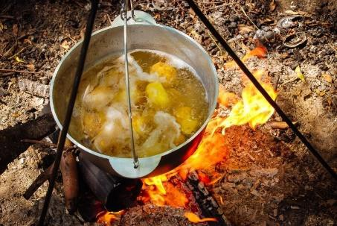The recipe being used will dictate the cooking method to be used.
The cooking style is often indicated on the menu, too.

Boiling
Boiling is the principle of cookery in which food is completely immersed in liquid and cooked at boiling point (100°C).
See online:
https://www.youtube.com/watch?v=FGvRniFAC1s – Fung Bros food: Boiling crabs
https://www.youtube.com/watch?v=A8yPmXpzkvU – The difference between boiling and simmering.

Poaching
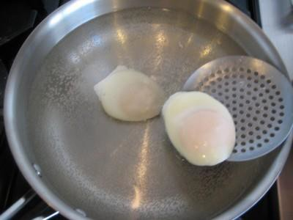Poaching is the principle of cookery where food is completely submerged in liquid just below boiling point: there should be no visible movement of the liquid.
See:
https://www.youtube.com/watch?v=cIvpbSEboYI – How to make the perfect poached eggs
https://www.youtube.com/watch?v=KtZ14xEbgzg – The simple way to poach an egg.

Braising
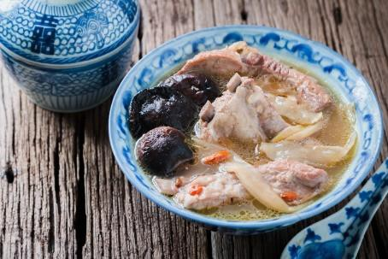Braising is the principle of cookery where food is half covered with an appropriate liquid and cooked slowly in a tightly lidded container.
The food is usually left in large pieces which are carved before serving: the cooking liquid for meat is often used in a sauce however the liquid in which vegetables are braised is not used for sauce as it is too strongly flavoured.
Braising can be done in an oven or on the top of the stove. Visit the websites below:
https://www.youtube.com/watch?v=pqpv_EkXhFg – How to braise https://www.youtube.com/watch?v=BZmVYtHejUY – Braising Stewing
Stewing is the principle of cookery where the food is completely covered with liquid while it is cooking. The long cooking process gives a concentrated flavour and the sauce which are served together as a complete dish.
Check the information at:
https://www.youtube.com/watch?v=-yrfpxKDzY4 – Stewing meat
https://www.youtube.com/watch?v=cVkZnUf1RuM – What’s the difference between braising and stewing?

Steaming
Steaming is the principle of cookery where food is cooked by steam, either at atmospheric or high pressure.
A smaller amount of liquid is used than in boiling. The food to be steamed is suspended above the liquid which creates the steam. The steam should be contained within the cooking vessel. Steaming is a very nutritional method of cookery as no fats or oils are used and natural tastes are preserved.
More information can be viewed at: https://www.youtube.com/watch?v=CXcmnl2o6IQ – Steam cooking food basics https://www.youtube.com/watch?v=Vmqfl3mxfK0 – How to steam vegetables

Deep frying
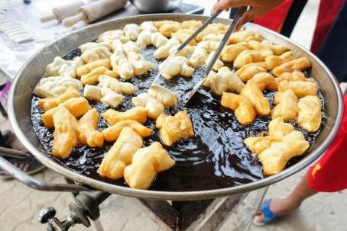Deep frying is the principle of cookery where food is cooked by total immersion in hot fat or oil. It is best suited to foods which can be cooked quickly.
Most foods need to be coated before deep frying to seal in the juices.
Watch the videos at:
https://www.youtube.com/watch?v=0y9fSgUwNuo – How to deep fry chicken
https://www.youtube.com/watch?v=RsCri2J3Ngk – How to make fish and chips

Baking
Baking is the principle of cookery in which food is subjected to the action of dry heat in an oven.
This dry heat is modified by steam produced by the water content of the food being baked.
See the following for more information:
https://www.youtube.com/playlist?list=PL2758929ECA7F0018 – to access a list of baking recipes and videos on how to make them

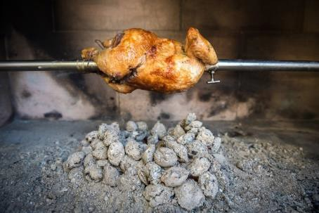Roasting
Roasting, and spit roasting, is the principle of cookery in which food is cooked in an oven or while rotating on a spit (see below).
Take the time to watch:
https://www.youtube.com/watch?v=SsHGYfIHS8o – How to cook the perfect roast (roast beef)
https://www.youtube.com/watch?v=c1_V2y_9KCM – How to make the ultimate slow-cooked beef pot roast

Grilling
Grilling is the principle of cookery where food is cooked by radiated heat directed from above or below: in some cases the heat can come from both directions at once.
The source of heat can be charcoal, coke, gas or electricity. See:
https://www.youtube.com/watch?v=V_yDTSrsv5g – The art of grilling: how to grill a steak https://www.youtube.com/watch?v=rEx9gPhtjzs – How to cook a steak with Gordon Ramsay

Shallow frying
Shallow frying is the principle of cookery where food is cooked in a small amount of fat in a pan or wok.
This principle also includes pan frying, sautéing and stir frying. Watch the following for more:
https://www.youtube.com/watch?v=_29Os6bcZYI – How to shallow fry and deep fry https://www.youtube.com/watch?v=8USTo7EqrI – Shallow fry.

Barbecuing
Barbecuing can be seen as:
- Using a barbecue to cook food
- Cooking on a hot plate, usually out-of-doors – either on a barbecue or over an open fire.
Popular items cooked this way include steaks, ribs, chops, cutlets, sausages, fish and a variety of vegetables such as tomatoes, onions, capsicums and corn.
Watch the following: https://www.youtube.com/watch?v=vpS5mHJBQDE – Barbecue chicken
https://www.youtube.com/watch?v=tC6keui55e8 – How to barbecue ribs.

Spit roasting
Spit roasting is the roasting of joints of meat, or entire animals (such as chickens, goat and pig which have been dressed) on a revolving spit.
Spit roasting may be achieved:
- Over an open fire
- Using a commercial spit roaster or rotisserie. It is critical to understand spit roasting:
- Is a popular cooking method for camps
- Takes time – and the process needs to commence well in advanced of expected service
- Is an art and a skill – only experienced persons should be used for the process and it should never be attempted for the first time for paying tour group members by those who have not had previous experience.
See http://www.lifestylefood.com.au/articles/top-5-tips-for-the-perfect-spit-roast.aspx and http://bbqspitrotisseries.blogspot.com.au/2012/06/spit-roasted-meat.html for more detail.

Dutch ovens
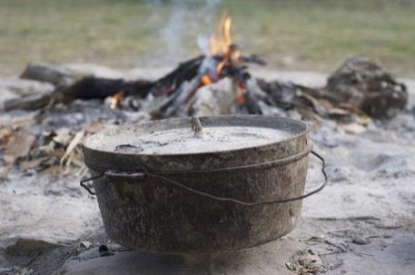These are essentially cast iron pots with lids which can be used to produce a wide variety of menu items by baking, stewing, deep frying and frying and can also be used for re- heating foods.
They are also called ‘camp ovens’.
They need to be seasoned before use and may be placed into the coals of an open fire or suspended (via a tripod) over an open fire.
Watch the following for more: https://www.youtube.com/watch?v=5J9amg4LHwY – Dutch oven cooking 101
https://www.youtube.com/watch?v=JaAhYGNlgfE – Dutch oven cooking: cooking breakfast https://www.youtube.com/watch?v=8IIly7se1pk – How to bake bread in a Dutch oven https://www.youtube.com/watch?v=1TRhLLjt_Nw – Dutch oven chicken.

Cooking in foil
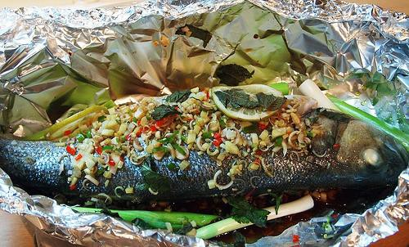For many tour group members food cooked in foil in a camp fire is the ultimate in camp site catering.
Food may be wrapped in foil and:
- Cooked in the coals of an open fire
- Cooked on a hot plate/barbecue Variations of this technique include:
- Cooking in leaves
- Cooking in bark.
See the following for more:
http://www.foodnetwork.com/recipes/articles/50-things-to-grill-in-foil.html - 50 things to grill in foil
http://www.artofmanliness.com/2010/07/20/cooking-around-the-campfire-9-easy-and- delicious-foil-packet-recipes/ - Cooking around the campfire: 9 easy delicious foil packet recipes.

Standard practices to be observed
The following need to be observed to ensure food and beverage safety and make sure the required quality standards are met:
- All food handlers hold a current and recognised food handling certificate
- Correct recipe has been selected and adhered to in all aspects
- Special requests/requirements of customers have been met, where possible
- All standard safe food practices have been implemented as part of the storage, preparation, cooking, holding and service processes

- Correct personal hygiene practices have been implemented during the preparation and other food handling phases
- Only clean items have been used to prepare and serve the food – meaning items must have been washed using detergent, sanitised and protected from contamination after cleaning
- All food used:
  - Has been obtained from reputable sources and complies with legislated requirements
  - Is checked and deemed safe before use
- Suspect food, food that has been dropped on the floor and food which does not comply with safe food handling protocols must be discarded and not served.

Drink production
For food safety purposes, beverages are the same as ‘food’ and need to be handled using the same safe food handling procedures applied to foods.
The following may be required in relation to drink production:
- Preparing a suitable range of garnishes and accompaniments – which may include:
  - Crushing ice
  - Slicing oranges and lemons
  - Preparing plastic drink decorations
- Pre-opening bottles, cans and other containers – as arranged for service with meals, such as:
  - Red and white table wine
  - Sparkling wine
  - Beer
  - Fruit juice
- Making drinks in advance of the meal/arrival of tour group members – as arranged for the meal, such as:
  - Fresh fruit juices
  - Punches
  - Cocktails
  - Pre-pouring drinks into jugs – for placement on tables/service to or for guests
  - Teas and coffees
- Checking glassware and jugs when handling them – to ensure:
  - They are clean not chipped or cracked
  - They are clean.

Confirm requirements of itinerary, as advertised

Introduction
Another task in preparing for camp catering is the confirmation of requirements as they were expected to be.
This section explains why this needs to done, and indicates how it may occur.

Need to confirm requirements
Confirming requirements can occur:
- Just before the camp site is reached
- On arrival at the camp – before food preparation and production begins.
It is important to confirm the itinerary requirements as a first-step when setting up catering for a camp site/tour in order to:
- Check the tour is still running according the planned itinerary – and to finalise service times.
There is always the possibility the tour is running early or late and so the catering may need to be adjusted to accommodate this change in timing.
- Determine final decisions about tour options – some tours may feature inclusions where tour group members can select some catering choices (menu items, service styles, eating indoors or out) as the tour proceeds.
In these cases, the catering crew needs to find out what the tour group has decided.
- Confirm tour group numbers – there may be cases where the tour group has grown or reduced in number and the camp crew need to know exact numbers they are catering for
- Identify special requests which may have emerged within the tour group – as tours progress it can become apparent certain tour group members have needs or preferences not known when the tour was planned/departed but which can be/need to be accommodated to optimise their satisfaction with the tour
- Ensure promises made are kept – for example:
  - Advertised items and meals are provided when and in the quantities advertised
  - Special event meals are served at the times and in the styles advertised. It is important to note:
- This confirmation can become a two-way process – that is, the catering crew can use this opportunity to notify the tour/Tour Leader of expected arrangements which cannot be accommodated.
For example, food for planned dishes/meals may have become unfit for consumption during transportation and be unavailable for service, or critical cooking equipment may have been lost or damaged.

This notification allows the Tour Leader to pre-warn the tour group, explain the reasons and prepare them for revised circumstances on arrival at the camp site saving the catering crew having to explain things and deal with the disappointments/complaints which may arise.
- 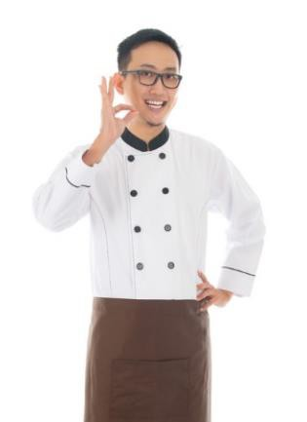The Catering crew will always carry a Tour Folder for every tour group containing:
  - Contact detail for the Tour Leader and other tour staff
  - Copies of the itinerary and inclusions
  - Copy of contract- for private tours
  - Copy of terms and Conditions of the tour
  - Tour operators policy manual
  - Standard recipes for planned meals
  - Relevant SOPs for camp catering
  - Plans developed for the tour and/or camp or destination
  - Site information – for the camp.

Ways to confirm requirements
There are a variety of ways in which requirements can be checked. They may involve:
- Communicating with head office/the tour operator
- Speaking with the tour group – usually in the form of the Tour Leader or, in some cases, the catering crew who are currently with that group.
Communication options may be:
- Via telephone – landline, cell, satellite
- Two-way radio
- Email exchanges.

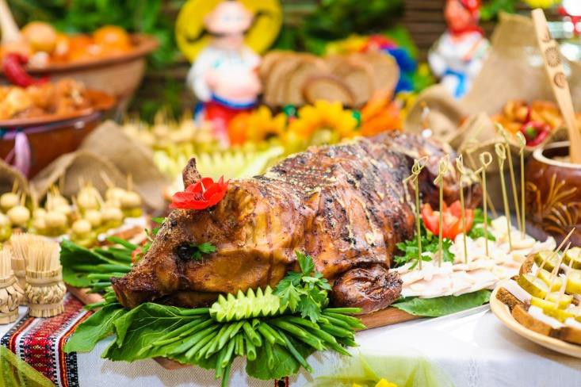

Work Projects
It is a requirement of this Unit you complete Work Projects as advised by your Trainer. You must submit documentation, suitable evidence or other relevant proof of completion of the project to your Trainer by the agreed date.

Note: this Work Project follows from the previous Work Project.

  - For the tour identified in Work Project 1.1 produce food providing evidence you have:

    - Applied food preparation techniques for the identified menu items
    - Applied food production techniques for the identified menu items
    - Confirmed requirements of itinerary, as advertised.

Summary
Produce food

When producing food:
- Perform required mise en place
- Wash and clean fruit and vegetables
- Peel, trim, cut and otherwise prepare ingredients as required
- Use standard recipes to produce menu items
- Apply a range of food production techniques
- Implement standard food safety practices throughout food preparation and production
- Include preparation of the bar/beverages as part of food preparation and production
- Accommodate special requests where feasible, possible, mandatory and/or within budget constraints
- Realise some camps/tours may provide for tour group members to have their catches cooked by catering staff
- Factor in potential for tour group members to cook their own food
- Confirm tour itinerary and respond to changes/issues arising on an ongoing basis.

Element 4: Serve meals

Prepare the dining area for service

Introduction
The first requirement for serving meals in a camp setting is to prepare the dining area for service.
This section identifies the basic options for dining areas, and presents activities to be addressed when getting ready to serve food.

The basic dining options
When on tour and in a camp setting the basic dining options are for tour group members to eat:
- 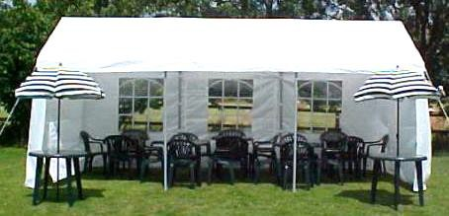In an area/dining facility provided at and by the destination where the camp is based – using those facilities and moving furniture (if possible) to suit tour group and individual mean requirements
- Outdoors – in the fresh air, where tour group members choose where they sit and take their meals where they want and select who they want to sit with
- Inside a tent/marquee – and are seated at tables and chairs to reflect group numbers and any required seating arrangements.

Activities to be addressed
When preparing the dining area for meal service there is/may be a need to:
- Cordon off the area – to:
  - Restrict access to the area during preparation so:
    - Set-up can occur without interruption
    - Tour group member safety is optimised
  - ‘Races’ can be created to control tour group access to food during self-service
- Ensure the cleanliness of the dining and service areas – this means:
  - Tidying and cleaning the area so it looks presentable – for example:
    - Putting things away
    - Removing litter
  - Taking action to make sure the area and facilities are hygienic - for example:
    - Using detergent to remove dirt
    - Applying sanitiser to remove bacteria

  - Protecting food/equipment from adverse weather
- 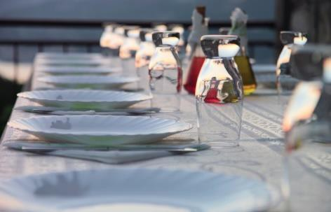Set-up tables and seating – taking into account:
  - Table plans/seating plans provided for the group
  - Accommodation for required numbers
  - Provision of sufficient seating
  - Convenience for tour group members
  - Location of/proximity to catering/food production area
  - Creating of, where necessary, a wind screen/other weather-related protection for diners
- Provide and/or adjust environmental elements to create suitable ambience where/if applicable – with reference to things such as:
  - Lighting
  - Heating/cooling
  - Music
- Provide required service items – which need to reflect the menu to be served and may necessitate laying/supplying clean and sufficient:
  - Cutlery
  - Crockery
  - Glassware
  - Single-use items
  - Serviettes
- Notify tour group members – in relation to:
  - The fact the meal is served
  - Options and choices available
  - Explanations of menu items and beverages
  - Seating and service arrangements.

Plate meals for service according to standard food presentation requirements

Introduction
When food has been prepared it will need to be plated for service.
This section looks at factors to consider in order to ensure quality and consistency in all meals which are served.

Options to plating meals
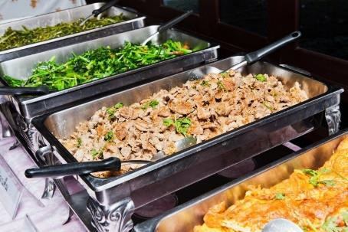It must be remembered not all food served to tour group members at camps will be plated.
Other options are:
- Food presented in food display and presentation equipment – for people to serve themselves
- Tour group members cook their own food – over a camp fire or using specialised cooking equipment/utensils.

Considerations when plating meals
Where meals are cooked by the kitchen crews and plated for service, the following points must to be taken into account – the need to:
- Check service plates prior to use – to ensure they are:
  - Clean
  - Free of chips and cracks
  - Correct type and size
- Adhere to planning tour standards regarding the quantity of food supplied – this volume of food may/will be:
  - Related to general tour standards established by the tour operator as being normal for general camp site catering
  - Specified via the individual contract agreed with the group in the case of custom tours
  - Directly linked to the number of people on the tour and expected at the meal service session
- Maintain food safety – throughout the entire process in terms of:
  - Food handling protocols
  - Personal hygiene practices
  - Food holding and presentation procedures
  - Utensils and equipment used for service
  - Crockery onto which food is plated

- 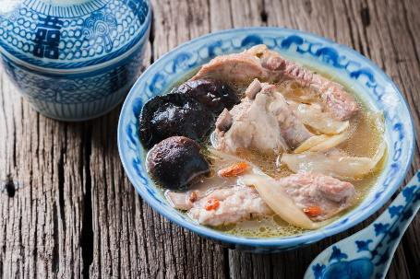Position food on plates – in a pre-arranged manner, such that:
  - Presentation is standardised across all meals of the same type which are served – so all meals look identical
  - The final/finished product looks attractive, appealing and enticing – because people first ‘eat with their eyes’
  - Colours are separated/contrasted on the plate
- Add accompaniments to each plate – as required, in terms of:
  - Garnishes
  - Sauces
- Wipe plates prior to service – in order to:
  - Meet customer expectations
  - Enhance presentation
  - Demonstrate professionalism
  - Remove smudges, drips, spills and finger marks
- Modify standard serve requirements – on the basis of:
  - Special requests made by tour group members – such as:
    - For ‘more’ or ‘less’ of an item
    - Not wanting certain food items
  - Common sense – with reference, for example to:
    - Serving less to children
    - Cutting back on serve sizes where an item is running out
- Ensure equality in serve sizes so each person has a meal of the same size unless otherwise requested – which can require:
  - Using the designated type/size of plate
  - Using nominated slotted/service spoons to serve items onto the plate
  - Counting items – individual units of (say) potatoes, slices of meat, pieces of fish
- Match plating with demand – to:
  - Enhance food quality – by serving, to the best extent possible, ‘to order’ so food is served immediately as opposed to losing quality/temperature by awaiting service
  - Meet immediate demand – as this may vary throughout the service session.

Display food for self-service as required

Introduction
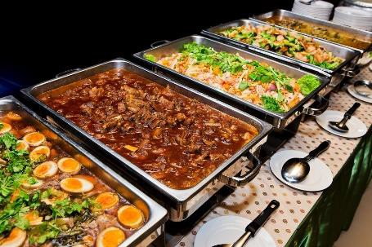Where food is to be provided for self-service it needs to be displayed properly for safe and appealing service.
This section identifies factors which must be observed when providing a self-service style of meal as part of camp catering.

Self-service factors to note

Context
Self-service is a service style where customers ‘help themselves’ to the food that has been prepared.
Catering staff are usually present and available to:
- Assist customers as required – with:
  - The service of food
  - Carrying meals to tables
  - Extra items as required – such as:
    - More/different condiments
    - Items to replace those which have been dropped on the ground
- Advise customers – about:
  - Recipes
  - Ingredients
  - Taste of the food.

Important service points
When involved in readying food for self-service it can be/is necessary to:
- Ensure all required display/presentations items have been suitably positioned – to:
  - Minimise travel of food from production area to service location
  - Facilitate self-service access by tour group members
- Verify service and display equipment has been prepared for service – that is:
  - Items are cleaned and sanitised
  - Bain maries for hot food have been pre-heated ready for use – hot food must never be placed into cold Bain Maries for service
  - Refrigerated service and display items need to be pre-chilled – so cold food is placed into cold equipment

- Position ancillary items ready for use – these may include:
  - Bread/rolls
  - Butter
  - Optional garnishes
  - Side dishes
  - Condiments
  - PC packs
- Fill service and display equipment – this:
  - Usually requires loading the prepared food into Bain Marie
trays or onto service platters and taking the food to the display units where it is placed into the unit
  - Necessitates careful handling of the food – to maintain/retain the best possible appearance
  - Should happen as close to expected service time as possible – to minimise the holding time of the food
- Maintain safe food temperatures – which may require (depending on the FSP for the operation):
  - Recording final cooking temperature of prepared food in the kitchen area
  - Taking and recording the temperature of the display/presentation units into which the prepared food is placed
  - Noting the time the food is placed in the refrigeration unit
  - Monitoring temperature of the food that is on display on an ongoing basis – to ensure food remains not only hot or cold (as required) but safe to consume
- Protect food from contamination – by following standard practices such as:
  - Checking/ensuring the integrity of food displayed for self-service during production and when it is transferred to the display units
  - Covering food whenever possible – while on display and during actual service
  - Not touching food with bare hands – to prevent contamination
  - Wearing disposable gloves when serving/handling food – to demonstrate safe food handling to customers and/or comply with requirements of the FSP
  - Eliminating pests/flies from the service area as best as can be achieved
  - Using sneeze guards, where practicable – to protect food from coughs and sneezes of users
  - Never using service gear which have been dropped on the floor/ground – without cleaning and sanitising in between
  - Not using service utensils which have been used by customers to eat/taste food – without cleaning and sanitising in between
  - Providing sufficient and suitable food service implements to facilitate self-service of food – so different service utensils are used for different foods and there is no need for customers to use the one utensil in multiple foods
  - Tasking staff with monitoring customer activity – so they might, as the need arises:
    - Remove contaminated food from display
    - Replace contaminated service gear
    - Provide help/advice to younger customers.

Serve beverages to accompany meals

Introduction
The service of beverages is a standard accompaniment to all meals served as part of camp site catering.
This section identifies considerations in this regard.

Considerations relating to the service of beverages
The following need to be observed when serving beverages as part of camp site catering:
- Realise from the viewpoint of food safety that beverages are food – so all the safe food hygiene protocols which apply to food need to apply to drinks
- Establish communal beverage service points – for self-service of hot and cold drinks. Locate these so they:
  - Avoid crowding at food service areas
  - Separate cold from hot drinks – to reduce congestion at each point
- Establish bar areas – for staff service of drinks:
  - Direct to customers
  - Using table service
- Prepare and present/provide service requisites – such as:
  - Glassware
  - Cups
  - Spoons
  - Milk
  - Tea and coffee
  - Drink garnishes and/or decorations
- Take necessary action to ensure beverages are served at the appropriate temperature – that is:
  - Hot drinks should be hot
  - Cold drinks should be cold
- Pre-open containers – in advance of service sessions as identified by pre-arranged beverage lists/requirements, and:
  - Mix drinks and decant bulk beverages into jugs and/or glasses ready for service and/or use by customers
  - Pre-pour beverages from containers – ready for:
    - Communal service points
    - Table service
    - Direct customer service

- 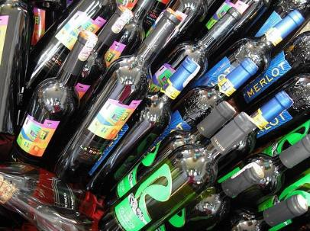Allocate nominated beverages to individual tables – in accordance with meal plan, by:
  - Type
  - Quantity
- Take drink orders – where:
  - Customers pay for each drink they order
  - A range of drink options is provided as part of the set menu
- Provide drinks advice – in terms of:
  - Making recommendations
  - Matching wine/s to food
  - Giving information on available beverages
  - Notifying tour group members about contents of pre-mixed drinks
- Prepare/mix drinks to meet individual need – ensuring:
  - A comprehensive knowledge of the beverages available – as there is always a restricted range of drinks and always a need to recommend alternatives
  - Standard portion control practices are observed – to:
    - Protect financial performance of the catering
    - Help drinkers control/monitor their alcohol intake
- Apply standard drink service protocols – including:
  - Not handling glasses by the top/rim of the glass
  - Washing/cleaning and drying glasses between uses
- Observe responsible service of alcohol practices – which (may) mean:
  - Complying with local liquor laws
  - Not serving minors
  - Not serving drunks
  - Only serving liquor to accompany meals
  - Not serving those who are not part of the tour group.

Replenish items throughout service

Introduction
There can be a need to replenish food and beverage items during service camp site catering sessions.
This section presents possible restrictions to this action, and lists activities inherent in this possible requirement.

Possible restrictions
For many camp site meal times there can be a need to replenish items during service.
In most cases this requirement may apply:
- Only to food provided in food display units at communal service points – and not to direct service to customers ‘at the table’
- Only to nominated food items – such as:
  - Bread/rolls and butter and/or vegetables and salad but not to central/protein elements of the meal
  - Certain courses of the meal – for example, entrees and desserts may be replenished but not main courses
- Only ‘on request’ – meaning additional items may not be offered but can be provided if asked for
- To a certain maximum limit – there is never/rarely unlimited amounts of food/beverages which can be provided
- Within set times – meaning there may be a time after which additional items will not be provided.

Replenishing items
Activities inherent in this possible requirement can include:
- Monitoring levels of food, beverage and other service requirements – by:
  - Observing the service session
  - Being alert to signals from customers they want service/need attention
  - Predicting need to re-supply items based on usage rates and numbers already served/numbers remaining to be served
  - Factoring in relevant factors as they apply to each service session – which may include:
    - Arrival patterns of customers
    - Profiles of customers
    - Customer satisfaction with/enjoyment of food and beverage items

- Taking action to physically add supplies to service points – as required in accordance with:
  - Actual usage levels
  - Estimated future usage
  - Amounts remaining/available to be served
- Advising kitchen staff/catering crew regarding usage – so they may, as appropriate to the tour (by type and budget):
  - Prepare more of the same food that is being used
  - Prepare different food items
- Implementing safe food hygiene practices – which can include:
  - Rotating stock and serving food that was prepared first, first – that is, applying FIFO stock rotation principles
  - Not mixing food batches
  - Applying safe food handling procedures when providing additional/extra items
- Replacing service and eating utensils – as required
- Replacing amounts of PC packs and single-use items – to prevent them running out.

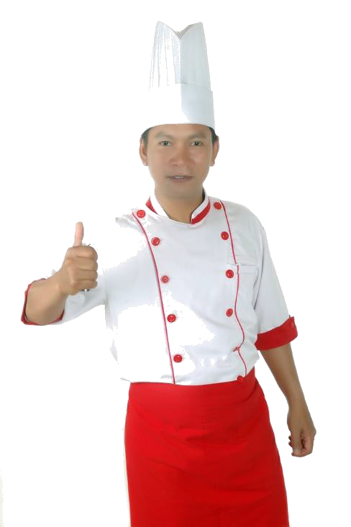

Establish rapport with tour group members

Introduction
Throughout all meal sessions there is a need for the catering staff to establish and maintain a positive relationship with tour group members.
This section indicates how this may be achieved.

Ways to develop a rapport with tour group members
When providing food and beverage service the following actions will combine to help service staff develop an effective rapport with tour group members:
- Greet customers – on their arrival at the food service area
- Use their name when talking to them – many will be wearing a name tag
- Smile when talking to them/serving them – it is truly a universal language understood by people from all countries
- Welcome them – to the food area and the meal/service session
- Individualise the communication – so it does not appear disinterested or robotic
- Explain food and beverage items – with attention to:
  - Describing ingredients, recipes and tastes
  - Highlighting what is included in the tour and what has to be paid for as an extra
  - Detailing any limits/restrictions which might apply to food, drinks, time, dining area, service
  - Recommending beverages (from the available list) to accompany meals
- Making food and beverage recommendations/suggestions – based on:
  - Asking questions to determine customers’ needs/preferences
  - Advising them based on personal experience
  - Availability of items including knowledge about stock levels and/or items which the bar/kitchen wants to ‘push’
  - Encouraging individuals to try something new or different
- Assist people to be seated – by:
  - Guiding/directing them to seats/tables
  - Helping them carry items/plates to their places
- Cater for individual need to the best extent possible – as this might apply to:
  - Assisting those with disabilities
  - Meeting special requests
  - Individualising service delivery

- Show respect for people – in terms of:
  - Using appropriate language/words and tone of voice
  - Adopting a professional manner
  - Being courteous and polite
  - Maintaining confidences
  - Not speaking badly of the employer or any tour group members
- Communicate with individuals when time exists to do so without adversely impacting service delivery – and:
  - Sharing their experiences of the tour
  - Seeking their feedback on the tour, food, beverages and service
  - Providing information – such as:
    - Giving details on history, communities, facilities and similar
    - Reminding tour group members not to feed local fauna
    - Advising on local laws and customs
- Resolve identified problems – within individual scope of authority
- Refer issues which cannot be successfully resolved – to Supervisor so they can take appropriate action.



Work Projects
It is a requirement of this Unit you complete Work Projects as advised by your Trainer. You must submit documentation, suitable evidence or other relevant proof of completion of the project to your Trainer by the agreed date.

Note: this Work Project follows from the previous Work Project.

  - For the tour identified in Work Project 1.1 serve meals providing evidence you have:

    - Prepared the dining area for service
    - Plated meals for service according to standard food presentation requirements
    - Displayed food for self-service as required
    - Served beverages to accompany meals
    - Replenished items throughout service
    - Established rapport with tour group members.

Summary
Serve meals

When serving meals:
- Clean the dining area
- Prepare for the area for food and beverage service
- Set-up to accommodate intended meals, service styles, numbers of tour group members and special requests
- Establish communal service points as required
- Plate meals for service if required
- Provide alternate service options as necessary
- Adhere to standard plating protocols to give portion control and consistency to finished products
- Monitor behaviour/actions of guests and respond where they create an unsafe food situation
- Implement safe food handling practices
- Serve drinks to accompany meals
- Advise and assist tour group members as part of service delivery
- Replenish items throughout service
- Create a memorable dining experience for tour group members.

Element 5:
Clear food and beverage items

Clear tables being used by tour group members

Introduction
Following meals there is always a need to clear food and beverage items. This section details the standard activities required to clear tables.

Clearing tables

Background
Every tour operator/catering crew will have their own individual protocols for clearing camp site tables.
Their SOPs will generally:
- Be variations on a theme – meaning they are all essentially the same
- Depend on the tour type – in that:
  - Actions for scheduled tours will stay the same for each type of standard tour
  - Special, one-off requirements can often apply to custom tours
– in terms of things such as:
    - Timing of clearing of courses
    - Number of staff to be used
    - Items to be cleared from, and items to remain on, the tables.

Indicative actions
The following may be required when clearing meal tables used by tour group members:
- Talking to diners as part of the clearing process – to:
  - Ask people for permission to clear their plates – as opposed to simply taking them
  - Develop/maintain rapport
- Clearing in a pre-determined manner – for example:
  - As individuals finish their meal
  - When a full table has completed their meal
  - At a set time
- Removing unused covers and items – from tables:
  - After first course has been started
  - On an ongoing basis on a course-by-course basis

- Following a uniform clearing method for all tables – such as:
  - Clearing to trays – and carrying trays to clearance points or the kitchen/dishwashing area
  - Using designated plate carrying protocols to remove items – such as (for example) the 2-plate carry, 3-plate carry or other
- Clearing all used food plates and cutlery from the same side of the diner – as determined by the service protocols of the tour operator/catering crew
- Not interrupting guests – if they are talking or still eating
- Returning unused food to the service area or kitchen – for:
  - Disposal – where SOP or FSP requires all left-over food is discarded
  - Storage for later use – where safe to do so
- Cleaning up spills – as they may occur during clearing
- Adjusting the cover as required – where, for example:
  - Have dropped an item on the ground
  - Have used the wrong item before its intended use
  - The next course requires additional/different items
- Picking up dropped items – including:
  - Food
  - Cutlery and other service items
  - Serviettes and other single-use items
  - Personal items of the diners
  - Waste/rubbish
- Wiping down and sanitising tables – which may be required:
  - In between courses
  - At the end of meals
- Communicating with the kitchen – to:
  - Advise of clearing progress
  - Give an indication of service time for next course
  - Pass on feedback received
  - Identify issues for future/next session.

Clear communal food and beverage service points

Introduction
At the end of a camp site service session there may be a need to clear communal service points.
This section identifies what is required where this need occurs.

Clearing communal F&B service points
Communal F&B service points which were established prior to service need to be cleared at the end of service.
(Note: In some camp situations a standard communal service point may remain ‘active’ all day/night providing people with water, tea and coffee, juice and a limited range of PC sweet biscuits, sliced cake or cheese and crackers.)
Basic requirements when clearing these communal service points may include:
- Asking people if they want to use the service point again – as it is about to close/be cleared, so they have a chance to get themself another drink/item
- Not clearing/taking down the service points until the correct time – this may be:
  - A pre-determined time
  - When all diners have left
  - As directed by the Supervisor
- Being quick, quiet and careful - so as to:
  - Minimise time spent on this activity
  - Avoid adverse impact of tour group
  - Prevent damage to equipment
  - Protect food/beverages which are safe to re-use/serve again
- Returning unused food to the service area or kitchen – for:
  - Disposal – where SOP or FSP requires all left-over food is discarded
  - Storage for later use – where safe to do so
- Cleaning up spills – as they:
  - Have occurred during service
  - Occur during clearing
- Picking up dropped items – including:
  - Food
  - Cutlery and other service items
  - Serviettes and other single-use items
  - Personal items of the diners
  - Waste/rubbish

- Wiping down and sanitising service point surfaces/tables – which may be required:
  - In between courses
  - At the end of meals
- Draining equipment – such as urns and wet Bain Maries, and:
  - Cleaning and drying them
  - Covering them and leaving them in place for next session
  - Removing them for bump out, as required.

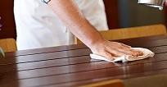

Tidy food production and service areas throughout service

Introduction
A standard requirement is the need to tidy both the food production area and the food service area throughout a meal service session.
This section explains why this is necessary and describes what is involved.

Need to tidy
Tidying food production and service areas during service is necessary to:
- Demonstrate professionalism – via implementation of standard F&B service protocols
- Build tour group member confidence in the competency of the tour operator – through the action of the catering crew
- Enhance the dining experience – as tour group members can see their needs are being catered for
- Meet customer expectations – regarding general activities related to food production and service
- Optimise food safety – through removal of materials which may cause contamination
- Improve the appearance of the areas – so the areas look more attractive
- Increase general safety – removal of rubbish can mean removal of risk
- Facilitate service – as things are replaced or put where they should be and everyone knows where to find them when they need them.

Tidying food production and service areas
Tidying the food production and service area may require:
- Cleaning up in-service spills – to:
  - Facilitate later/full cleaning – making the final cleaning of the areas quicker/easier
  - Enhance the immediate operational safety of the area – by getting rid of potential causes of ‘slips and trips’
  - Remove food sources which may attract pests
- Picking up dropped items – including:
  - Food – and disposing of all food that has been dropped on the floor
  - Cutlery – and replacing same for diners where required
  - Serviettes – to keep the service area neat, replacing them for people as necessary
  - Personal items accidentally dropped by customers – as a professional service and courteous act

- Wiping down and sanitising service areas and equipment – as planned, which may mean:
  - Cleaning with a nominated cloth and using a nominated chemical to sanitise after the clearing of identified courses
  - Cleaning at a given time of the day – such as every four hours, regardless
- Removing food debris and other rubbish – to:
  - Designated rubbish containers – in the service area and/or the kitchen area, which may require separation of:
    - Food waste
    - General waste
    - Recyclable materials
  - Designated areas – which may be:
    - Specified by the camp site owners/operators
    - Created by the camp catering crew especially for the tour
- Maintaining general hygienic conditions in food production and service areas – which can involve:
  - Undertaking pest management/control – to limit flies, insects and other pests/rodents
  - Monitoring food – to ensure it remains fit for human consumption or is thrown out
  - Protecting and/or covering food – from flies, dust and other contamination
  - Checking temperature and condition of food – as part of other service-related and tidying duties
  - Making sure food handlers wash their hands after handling rubbish/undertaking cleaning and before handing food/food items again
- Maintaining an attractive and acceptable visual appearance of the kitchen and service areas – which must involve:
  - Seeing things through the eyes of the customers/tour group members
  - Realising a tidy/professional appearance is a legitimate and important element of the total service experience
  - Understanding the strong and direct link which often occurs between tidiness and cleanliness – that is, areas which are tidy are often also areas which are clean
- Ensuring food production and service takes precedence over non-essential cleaning and tidying duties – such that:
  - Making and serving food takes priority over tidying and cleaning
  - Customers should never be forced to wait while cleaning and tidying occurs
  - Workers should:
    - Use the ‘small change’ of time to clean and tidy
    - Try to do two things at once – for example, tidy a table as they clear it
    - Try to take something out of the service area when they leave it – and not leave empty-handed.

Maintain on-going interaction with tour group members

Introduction
Excellent service requires service staff maintain a positive on- going relationship with tour group members during the clearing of food and beverage items.
This section identifies techniques to ensure this happens.

Ways to maintain rapport with group
When clearing food and beverage items the following techniques have proved to be effective for service staff in maintaining and extending a positive relationship with tour group members:
- Remember the tour, the camp and the meal are being provided for the tour group members – so:
  - Give tour group members right-of-way – let them ‘go first’: do not get in their way or push through them
  - Do not interrupt them
  - Never do work to annoy them or distract from their enjoyment or experience’
  - Take care – not to bump into people or knock them or their belongings
- Ask permission – to:
  - Clear and clean
  - Take items, plates and glasses.
Never assume things are ready to be taken
- Be polite and courteous – which means:
  - Saying ‘please’ and ‘thank you
  - Using people’s names
  - Knowing when to engage with people – and when to keep quiet and leave people alone
  - Refraining from complaining to customers – about the supervisor, work, conditions, pay
- Communicate with people – which may involve:
  - Asking how they enjoyed their meal and seeking feedback on the service
  - Seeking suggestions for change/improvement
  - Identifying and resolving complaints
  - Providing local information
  - Using positive body language – and smiling
  - Monitoring/reading the non-verbal communication of diners – to help detect if there is a problem/issue which needs to be addressed

- Share their experience (but not allowing this to dominate the work that needs to be done and not allowing one customer to feel others are receiving preferential treatment) – which can be done by:
  - Following-up on previous conversations – in which tour group members have indicated where they are going and what they are going to do
  - Asking where they have already been and what they have already done
  - Enquiring what they are doing next/tomorrow
  - Listening to their tales/anecdotes
  - Giving tips/advice on up-coming activities and destinations – so they get the most from them
- Make relevant offers of help – such as:
  - Providing ‘extras’ where possible/within scope of authority or budget – such as:
    - Another drink
    - A snack to take away
  - Promising to find out if a special request can be accommodated
  - Finding out what is on the menu tomorrow/next meal
  - Notifying Supervisor where tour group members require their attention to deal with an issue.

Dispose of unwanted items and materials throughout service

Introduction
Standard service practice is to dispose of unwanted items and food throughout the course of a meal.
This section discusses what is required in this regard.

Waste disposal during service
During service sessions there can be a need to:
- Remove used/dirty items from tables and/or service points – for:
  - Clearance to washing areas
  - Disposal as appropriate.
House/tour operator specifications will determine how this is done – options include:
  - By hand/carrying items in hands
  - By tray/carrying items on a (service) tray
- Take damaged items out of service – and remove them, as relevant, to:
  - An area for later repairs/maintenance
  - To a waste area where the item needs to be disposed of – note there can be a need to transport some damaged items back to head office for disposal there as suitable disposal areas do not always exist at every camp site
- Dispose of all items in an environmentally-sensitive manner – see section 6.1
- Make sure food handlers observe safe food handling protocols when dealing with waste – which may require/include:
  - Washing their hands after handling waste/rubbish and before handling food/food items again
  - Wearing protective gloves when handling rubbish
  - Protecting food from contamination by waste:
    - Through physical separation
    - By covering food, food surfaces and food items
- Always be alert to the possible need to remove/clear items – whenever leaving the service area in order to:
  - Never leave the dining area empty-handed
  - Reduce time required for clearing at other times during service
  - Make room/space for fresh items to be brought in to the dining areas/placed on tables and at communal service points.

Work Projects
It is a requirement of this Unit you complete Work Projects as advised by your Trainer. You must submit documentation, suitable evidence or other relevant proof of completion of the project to your Trainer by the agreed date.

Note: this Work Project follows from the previous Work Project.

  - For the tour identified in Work Project 1.1 clear food and beverage items providing evidence you have:

    - Cleared tables being used by tour group members
    - Cleared communal food and beverage service points
    - Tidied food production and service areas throughout service
    - Maintained on-going interaction with tour group members
    - Disposed of unwanted items and materials throughout service.

Summary
Clear food and beverage items

When clearing food and beverage items:
- Clear in accordance with established protocols or specified requirements for each meal/service session
- Maintain rapport with tour group members as part of the clearing process
- Be observant and use common sense
- Ask permission to take items/clear plates and glasses
- Clean up spills and dropped items as part of the process
- Wipe down/sanitise tables as required
- Communicate with the kitchen and keep them informed
- Take down communal service points at pre-determined times
- Notify tour group members of impending closure of communal service points prior to closing them
- Tidy dining area throughout the service period
- Help food production staff to tidy the kitchen area
- Dispose of waste and unwanted items during service on an ongoing basis
- Maintain safe food handling protocols.

Element 6:
Finalise service session

Dispose of unwanted items

Introduction
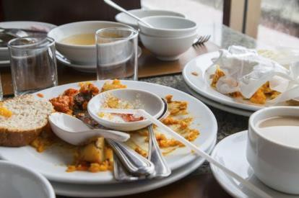A standard requirement when finalising a service session is the need to dispose of unwanted items.
This section defines ‘unwanted items’ in this context and describes possible activities needed to dispose of them.

‘Unwanted items’
In this context ‘unwanted items’ may be seen as:
- Plate waste – which is food left on the plates by diners when they finish a meal
- Left-over food – as produced by the catering crew and:
  - Not consumed/served to tour group members
  - Not suitable for storage for later use
  - Unable to be safely stored for future use
  - Banned from storage under the FSP in operation for the camp
- Used single-use items – such as:
  - Plastic cutlery
  - Foam cups
  - Disposable food and drink containers
  - Drinking straws and hot drink stirrers
  - Paper serviettes/napkins.
These items will be dirty and must be disposed of and cannot be cleaned (washed/sanitised) for re-use as they are designed and intended to be used only once.
- Wrapping from the range of portion-control packs served to/used by the tour group members – which may need to be separated into general waste or recyclable materials
- Empty containers and materials resulting from the food production process – such as:
  - Tins/cans
  - Cardboard cartons
  - Glass and jars
  - Food wrapping and packaging materials
  - Aluminium foil and cling wrap

- 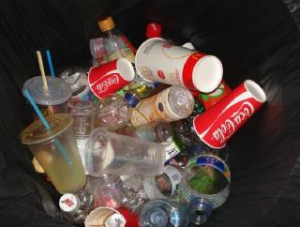Empty containers generated as a result of the beverage production and service process – such as:
  - Bottles
  - Cans
  - Drink cartons
- Litter – this is general waste and rubbish:
  - Produced by tour group members while in camp/in the dining area
  - Generated by the crew as a consequence of their work and/or social activities
- Empty chemical containers – generated as a result of cleaning activities.
These containers may be ‘deposit paid’ containers and, if so, will need to be returned to head office so they can be returned to collect the deposit.

Activities involved
Generic activities possibly required when disposing of unwanted items might include:
- Disposing of all items in an environmentally-sensitive manner – in accordance with:
  - Site requirements
  - Contracted arrangements
  - Agreements with local communities
  - Local legislation
- Packing/bagging and stowing of rubbish – for:
  - Carrying away when leaving the camp/returning to base
  - Later disposal at an approved waste disposal area, where no facilities exist on-site
- Storing food waste under refrigeration – to:
  - Help reduce spoilage and odour
  - Provide protection against access by pests/animals
- Keeping waste which has to be transported off-site separate from food which is also being transported – this:
  - Is to prevent contamination
  - May require storage of waste in a separate vehicle to ‘food’ transport vehicles
- Not feeding left-over food or plate waste to local fauna – which can involve:
  - Informing tour group members not to feed the wildlife
  - Training staff not to do so
  - Monitoring tour group members to ensure they comply

- Separating items to accommodate local waste disposal requirements – which may require separation of rubbish/waste into:
  - General waste, rubbish and litter
  - Food waste
  - Recyclable materials
  - Oil – from fryers/cooking
- Not leaving any waste/rubbish on-site/in the local area – which may involve:
  - An inspection by a local person to confirm all waste/rubbish has been removed
  - Not burying waste on-site – as animals can dig it up
  - Forfeiting a deposit if the area is not properly cleaned
  - The tour operator:
    - Having to pay a charge if the site has to be cleaned by others after the tour has departed
    - Being refused future access to the site if it is not left as required
- Securing food waste – in metal containers with tight lids so that:
  - It does not attract pests and local wildlife
  - It cannot be accessed by animals, birds and pests.

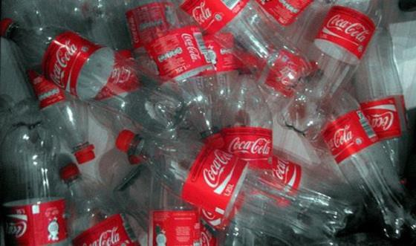

Clean and sanitise equipment and utensils used in the storage, preparation, production and service of food and beverages

Introduction
All equipment and utensils used in the storage, preparation, production and service of food and beverages for camp site catering will need to be cleaned and sanitised.
This section discusses options and considerations in this regard and gives standard requirements relating to the cleaning and storage of these items.

Cleaning options and considerations
It is important to understand:
- Some camps will not wash/clean equipment and utensils after use – they may decide to:
  - Load the used/dirty items for transport back to the head office
  - Clean and sanitise items on return
- Where equipment and utensils are used for dinner/evening meal there will normally be a requirements to clean and sanitise items so they can be used for breakfast – unless sufficient additional items have been loaded/are available
- Water can be a precious and scarce commodity in some areas – so:
  - It needs to be used wisely
  - Limits may apply to quantities available
  - Hand sanitiser may be provided for tour group members and staff
- Some camps/sites may have restrictions or requirements about:
  - Cleaning activities that can be undertaken
  - Chemicals that can be used
  - Management/control and disposal of waste water generated as a result of washing and cleaning activities
- Established/commercial camp sites may feature industrial dishwashing and pot washing facilities – with:
  - Pre-wash sprays
  - Pot wash and soaking sinks
  - Dishwashing machines
- Many camps especially in remote areas will need to use hand-washing – to clean glasses, dishes, equipment and utensils.
The use of hand-washing is effective and safe providing a two-bowl approach is used as described below.

- A known lack of facilities to support the safe cleaning and sanitising of items at a camp site should be taken into account as part of the planning process – in terms of:
  - Serving menu items which can be prepared in advance and transported to the site ready for service – or re-heating and service (rather than cooking/production)
  - Using disposable service wear – plates, cutlery, plastic glasses
- Cleaning is the removal of visible dirt and debris (including objectionable odour) – from crockery, cutlery, glasses, equipment, utensils or fixtures and fittings.
Sanitation is the killing of microbes using either hot water and/or chemicals.
Cleaning is performed before sanitation and where chemicals are used, the manufacturer's instructions in relation to dilution rates, contact time and temperature must be adhered to.

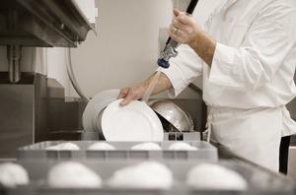Two-bowl dish washing
When using a double bowl sink to wash eating utensils and dishes:
- One bowl must contain water at 45°C and detergent, for washing
- One bowl must contain clean water at a minimum of 77°C for sanitising
- Sanitising must involve soaking the items for a minimum of three minutes – it is not acceptable to just pour hot water over items to remove the suds
- Water needs to be changed regularly to keep it clean
- A thermometer must be on hand to check water temperature.
In general terms, the following sequence is suitable for cleaning crockery and cutlery:
- Remove visible food debris – for example, scrape the plates
- Rinse with warm water – to remove loose dirt
- Wash with a detergent
- Rinse again – to remove the detergent and debris
- Apply a sanitiser – sanitisers are chemicals designed to kill bacteria
- Rinse – to remove the sanitiser
- Allow to air dry.
  - Air drying is the preferred option as it eliminates using a cloth to dry surfaces, which may inadvertently introduce bacteria to the surface that has just been cleaned and sanitised.
Using a dishwashing machine
The procedure for washing eating utensils and dishes by machine is as follows:
- Scrape and rinse items prior to stacking in trays – use the right trays/racks for the right items
- Wash for a minimum of 60 seconds at a temperature between 66°C and 71°C
- Rinse for a minimum of 10 seconds at a temperature of at least 77°C.

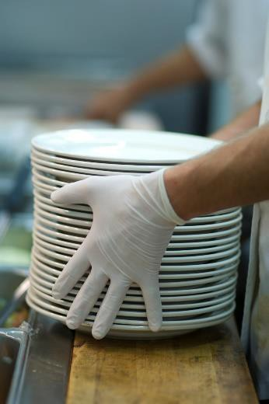Standard requirements
The following provide a representative list of standard requirements which may need to be applied when cleaning and storing camp site catering F&B equipment and utensils:
- A food safety plan/program for the camp should be available – in order:
  - To provide guidance and direction for employees as/if required
  - To optimise likelihood of maintaining food safety for the tour
  - To provide specific cleaning and sanitation instructions for individual items of equipment and utensils
- Staff used to clean and sanitise equipment and utensils must be properly trained – which can mean:
  - They may need to hold a recognised food handling qualification
  - They should have received practical training (demonstration and drill/practice) in the cleaning and sanitising of items under simulated camp situations
- Required chemicals need to be taken – as part of standard tour/catering resources, in terms of (for example):
  - De-greaser – for cutting/removing heavy grease
  - Suitable detergents – of required types and strengths/active ingredients to cope with expected need as indicated by menu planning
  - Sanitiser
  - Glass washing detergent
  - General purpose cleaners
  - Stainless steel clean cleaners –where portable/mobile equipment of this type is used, or it is known to exist as part of the available kitchen area/facilities
- All food contact surfaces must be cleaned, when in constant use, at least once every four hours – to help prevent contamination
- Cleaning low risk areas and equipment before cleaning high risk areas – when the same cleaning items/equipment have to be used
- Unless items are being transported back to head office for cleaning and sanitation, they need to be cleaned as soon as practicable – as:
  - This makes things easier to clean
  - Decreases potential for contamination
  - Reduces potential for soiled items to attract pests
- Store cleaned and sanitised equipment and utensils properly after cleaning – to protect them from re-contamination
- All items need to be cleaned after use – this can necessitate washing and sanitising of:
  - Food storage equipment
  - Food preparation equipment and utensils – including any surface that makes contact with food
  - Food production equipment and utensils – including large and small equipment
  - Food service equipment and utensils
  - Dining equipment – including crockery, cutlery and glassware.

Clean and tidy the food production and dining area

Introduction
In addition to cleaning and sanitising equipment and utensils there is also a need to clean and tidy the food production and dining area at the conclusion of the camp/tour.
This section identifies actions which may need to be taken to complete the final clean-up for the kitchen and eating areas.

Activities required
The following may be required when finalising cleanliness of food production and dining areas:
- Cleaning tables – this applies to:
  - Portable tables which will be returned to head office – which will commonly not be sanitised at this stage
  - Tables provided by camp administration/owners on-site in the camp – which will also be sanitised
- Cleaning chairs and other seating arrangements – as above
- Picking up litter – left/generated by the tour group from rooms, areas and equipment, fixtures and fittings
- Cleaning up spills – which may have occurred:
  - In the kitchen area during the food production process – and which may have been cleaned up quickly on-the-spot at the time of the spill happened, but still require a final/proper/more comprehensive cleaning
  - On the ground – in the dining/service area as a result of spills or food dropped by tour group members
  - On furniture and/or equipment
- Cleaning the general area – which may entail:
  - Returning the areas to the original condition in which they were provided
  - Improving the condition of areas beyond that in which they were found to the greatest extent possible
- Disposing of rubbish and litter:
  - In an environmentally-sensitive manner – as identified in earlier notes
  - By removing it for disposal in an alternate location
  - In compliance with all relevant laws
- Re-positioning camp site items which may have been moved – by:
  - Tour group members
  - Tour staff for the purposes of activities/recreation
  - Food production and service staff

- Closing and/or locking entry doors, gates and access points – to things such as:
  - Ablution blocks/facilities
  - Cupboards and cabinets in food production and service areas
  - Food production and dining areas
  - Sites
- Turning off and/or disconnecting:
  - Electrical power
  - Gas
  - Water
  - Nominated items
- Conducting a final visual inspection – which:
  - Is done to find items which may have been dropped, forgotten or overlooked by the crew and/or tour group members
  - May be done in partnership with site representative
  - Could require completion of ‘On departure’ checklist to provide evidence of the inspection and form a basis for recording issues
  - Often forms the basis of reimbursement of bonds paid and/or extra charges levied
- Liaising with site owners, where applicable – to:
  - Confirm that the areas have been cleaned to their satisfaction
  - Identify areas requiring further attention
  - Negotiating payment/recompense in accordance with identified issues.



Disassemble food related equipment for transport or later use

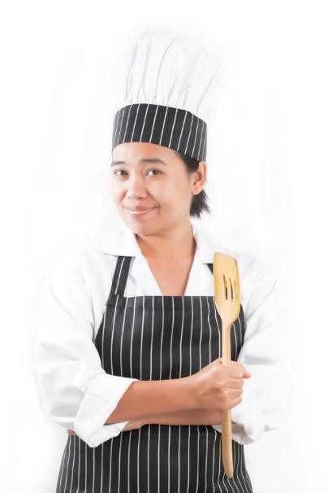Introduction
Before bump out can occur there may be a need to disassemble food related equipment for transport or later use.
This section discusses requirements in this regard.

Disassembling food related equipment
The following protocols generally apply to the disassembly of food-related equipment when bumping out:
- Items which needed to be assembled for use usually need to be disassembled when finalising the camp – this is not always the case but is a good ‘rule of thumb’.
In general, items are more likely to be damaged and/or
not fit into available space if they are left assembled for transportation.
- Where possible, equipment is cleaned as it is disassembled.
This cleaning may not need to be a thorough cleaning but it should at least remove ‘loose dirt’ and grease/oil/grime which may be transferred to other items or the transport vehicle. Fuller cleaning may be more easily undertaken back at head office where better facilities exist.
Sanitation normally does not occur at this point because the equipment is not about to be used and will require cleaning/wiping, washing after it has been re-assembled for its next use.
- All parts from the one unit must be included with that unit – the parts may need to be placed into a designated, tagged bag
- The correct tools must be used to disassemble units – to avoid damage to nuts, bolts. connections and hoses
- Equipment should be inspected for damage as part of the disassembly process – and supervisors advised of identified problems so appropriate remedial action relating (for example) to repairs or securing substitute equipment can be taken
- Care should be taken when handling items/equipment at this stage – to:
  - Avoid damage to equipment
  - Avoid personal injury
  - Maintain cleanliness of items after disassembly.

Stow equipment, resources and supplies for transport or later use

Introduction
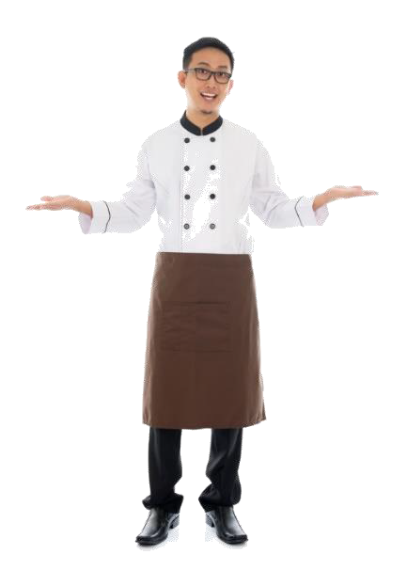A final activity when breaking a camp/departing a camp site is the need to stow equipment, resources and supplies for transport or later use.
This section lists indicative considerations when undertaking these closing down/bumping out procedures.

Stowing items for forward movement
All the following need to be taken into account when stowing equipment, resources and supplies for transport or later use:
- Equipment is normally loaded for transportation from the camp in the same location and/or vehicle as it was brought to the camp – this standardised pattern/location of equipment:
  - Speeds up the loading process
  - Ensures all items can be accommodated
- Safe manual handling techniques need to be observed – which frequently indicates need for a team lift as many pieces of food equipment are large, awkward and/or heavy
- Larger items are usually loaded before smaller items – and the smaller items are loaded:
  - ‘In and around’ the bigger ones
  - Last
- Boxes used to carry equipment in to the camp are used to carry the items out of the camp
– in particular:
  - These crates and cartons are often purpose-built to suit individual items of equipment and will safely house and properly protect sensitive/fragile aspects such as knobs, dials, gauges, connections and linkages
  - Loading smaller items into boxes speeds up the loading process by reducing the number of trips which have to be made to the transport vehicle
  - Stowing boxes (which are usually of a rectangular-shape) is easier and more secure than trying to stow lots of smaller items
- Loading sheets should be used/completed as part of the process – to verify all items carried in were, in fact, taken out/back
- Attention needs to be paid to loading and stowing the equipment safely and securely – to:
  - Prevent movement during travel
  - Avoid damage in transit
  - Deter unauthorised access/theft

- If possible, stowing should occur during daylight hours and not at night.
Even with artificial lighting, it is often still too difficult to see clearly and there is too much potential for accident, damage and for smaller items to be overlooked, forgotten and lost.
It is generally much better for equipment and supplies to be stowed ‘next day’ – not only is there better light but staff are generally better rested
- Stowing of food waste to be taken away from the camp site needs to be planned in advance – so that:
  - It is separated from and unable to contaminate foodstuffs
  - It does not present an odour problem to tour group members travelling in the vehicles
  - It is secured or contained in such a way there is no leakage.



Work Projects
It is a requirement of this Unit you complete Work Projects as advised by your Trainer. You must submit documentation, suitable evidence or other relevant proof of completion of the project to your Trainer by the agreed date.

Note: this Work Project follows from the previous Work Project.

  - For the tour identified in Work Project 1.1 finalise service session providing evidence you have:

    - Disposed of unwanted items
    - Cleaned and sanitised equipment and utensils used in the storage, preparation, production and service of food and beverages
    - Cleaned and tidied the food production and dining area
    - Disassembled food related equipment for transport or later use
    - Stowed equipment, resources and supplies for transport or later use.

121
© ASEAN 2015
Trainee Manual
Summary
Finalise service session

When finalising service session:
- Dispose of waste and unwanted items in accordance with organisational SOPs
- Observe all local laws in relation to waste disposal
- Maintain safe food handling procedures
- Take care to protect food and other resources from damage or loss
- Clean equipment and utensils on-site after use, if planned and/or possible or practicable
- Disassemble equipment for transport
- Clean equipment as part of the disassembling process
- Stow equipment , utensils and resources for travel in designated vehicles and locations
- Pay special attention to waste what has to be transported
- Secure and protect all stowed items loaded for transport
- Use a Loading Sheet to guide loading and stowing of items
- Tidy all areas prior to finalising the camp
- Return camp to original or better condition
- Inspect the area prior to departure
- Turn off required items
- Close and locks doors and access as required
- Liaise with site management, where required, as part of finalisation procedures.

122
© ASEAN 2015
Trainee Manual

Presentation of written work

Presentation of written work

Introduction
It is important for students to present carefully prepared written work. Written presentation in industry must be professional in appearance and accurate in content. If students develop good writing skills whilst studying, they are able to easily transfer those skills to the workplace.

Style



- Plan ahead
Students should write in a style that is simple and concise. Short sentences and paragraphs are easier to read and understand. It helps to write a plan and at least one draft of the written work so that the final product will be well organised. The points presented will then follow a logical sequence and be relevant. Students should frequently refer to the question asked, to keep ‘on track’. Teachers recognise and are critical of work that does not answer the question, or is ‘padded’ with irrelevant material. In summary, remember to:

- Be clear and concise
- Answer the question
- Proofread the final draft.

Presenting Written Work

Types of written work
Students may be asked to write:
- Short and long reports
- Essays
- Records of interviews
- Questionnaires
- Business letters
- Resumes.

Format
All written work should be presented on A4 paper, single-sided with a left-hand margin. If work is word-processed, one-and-a-half or double spacing should be used. Handwritten work must be legible and should also be well spaced to allow for ease of reading. New paragraphs should not be indented but should be separated by a space. Pages must be numbered. If headings are also to be numbered, students should use a logical and sequential system of numbering.

123
© ASEAN 2015
Trainee Manual

124
© ASEAN 2015
Trainee Manual

Presentation of written work

Cover Sheet
All written work should be submitted with a cover sheet stapled to the front that contains:
- The student’s name and student number
- The name of the class/unit
- The due date of the work
- The title of the work
- The teacher’s name
- A signed declaration that the work does not involve plagiarism.

Keeping a Copy
Students must keep a copy of the written work in case it is lost. This rarely happens but it can be disastrous if a copy has not been kept.

Inclusive language
This means language that includes every section of the population. For instance, if a student were to write ‘A nurse is responsible for the patients in her care at all times’ it would be implying that all nurses are female and would be excluding male nurses.
Examples of appropriate language are shown on the right:

Mankind
Humankind
Barman/maid
Bar attendant
Host/hostess
Host
Waiter/waitress
Waiter or waiting staff

125
© ASEAN 2015
Trainee Manual

Recommended reading

Recommended reading

Sourced from ‘Trove: National Library of Australia’ at http://trove.nla.gov.au/.
BLAKE, JOAN SALGE 2012, Hospitality & tourism management program (htmp) year 1 workbook package, Prentice hall, [s.l.]
Brown, Douglas Robert & Henkel, Shri L., 1965- 2007, The non-commercial food service manager's handbook : a complete guide for hospitals, nursing homes, military, prisons, schools, and churches, with companion CD-ROM, Atlantic Pub, Ocala, Fla
Buckley, Ralf 2010-09-24, Adventure Tourism, Elsevier
Gisslen, Wayne 2015, Professional cooking, Eighth edition, Hoboken, New Jersey John Wiley & Sons, Inc
LEWIS, JOAN E 2013, Culinary professional, Goodheart-willcox co, [s.l.] Nickens, T. Edward 2015, Field & stream's guide to camping
Rasinski, Timothy V 2012, Hospitality & tourism management program (htmp) year 1 student textbook, Prentice hall, [s.l.]
Rock, Gordon 2015, Dutch oven cookbook for meals and desserts : a Dutch oven camping cookbook full with delicious Dutch oven recipes, [United States] [Createspace]

Other references
CSIRO, 2010, Make it safe: a guide to food safety, CSIRO Publishing, Collingwood, Victoria

Counihan. C. & Van Esterik, P., 2112 (3rd ed‟n), Food and culture – a reader, Routledge, NY

Cousins, J., 2010, Essential food and beverage service for levels 1 and 2, Hodder Education, London

Cracknell H.L. & Kaufman R.J., Revised Third Edition, 1999; Practical Professional Cookery; The Macmillan Press Ltd, UK

Dark, D., McLean D. and Weatherhead, S., 2003; The professional cook’s book: kitchen operations 2nd Ed; Tertiary Press Australia

Ford, J., Zelman, M., Hunter, G., Tinton, T., Carey, P., Walpole, S. and Rippington, N. 2010;
Professional Chef; Cengage Learning, Australia

Hickman, A., 2008, Follow workplace hygiene procedures: SITXOHS002A, William Angliss Institute, Melbourne, Australia

Hickman, A., 2008, Implement food safety procedures: SITXFSA001A, William Angliss Institute, Melbourne, Australia

Lillicrap, D.R., Cousins, J. & Smith, R., 2010 (8th ed‟n), Food and beverage service, Hodder Education, London

126
© ASEAN 2015
Trainee Manual

Recommended reading

McGee H., 2004; McGee on food and cooking: an encyclopedia of kitchen science, history and culture; Hodder & Stoughton, United Kingdom.

McLean, D., Satori. L, Walsh C and Walsh S, 2004; The professional cook’s book: commercial cookery; Tertiary Press, Australia
McVety, P.J., 2009 (3rd ed‟n), Fundamentals of menu planning, John Wiley & Sons, Hoboken, NJ

O‘Meara M., 2009; Food Safari: Glorious Adventures through a World of Cuisines; Hardie Grant, Melbourne Whitney, Ellie et al; 2011 (1st Edition); Understanding Nutrition: Australian and New Zealand Edition; Cengage

Rey, M.A. & Wieland, F., 2012 (4th ed‟n), Managing service in food and beverage operations, Educational Institute of the American Hotel & Lodging, Lansing, Mich

Safe Food Australia – available through http://www.foodstandards.gov.au/publications/pages/safefoodaustralia2nd519.aspx

Trainee evaluation sheet

Provide camp site catering
The following statements are about the competency you have just completed.

Please tick the appropriate box | Agree | Don’t Know | Do Not Agree | Does Not Apply
There was too much in this competency to cover without rushing.
Most of the competency seemed relevant to me.
The competency was at the right level for me.
I got enough help from my trainer.
The amount of activities was sufficient.
The competency allowed me to use my own initiative.
My training was well-organised.
My trainer had time to answer my questions.
I understood how I was going to be assessed.
I was given enough time to practice.
My trainer feedback was useful.
Enough equipment was available and it worked well.
The activities were too hard for me.

The best things about this unit were:

The worst things about this unit were:

The things you should change in this unit are:

Trainee self-assessment checklist
As an indicator to your Trainer/Assessor of your readiness for assessment in this unit please complete the following and hand to your Trainer/Assessor.

Provide camp site catering

 |  | Yes | No*
Element 1: Determine camp site catering needs
1.1 | Identify tour group requirements
1.2 | Develop menus for the tour itinerary
1.3 | Verify planned menus with management or tour group members
1.4 | Identify equipment and resources required to support menus
1.5 | Stow equipment, resources and supplies for transportation to camp site
Element 2: Prepare the catering area
2.1 | Establish the catering area
2.2 | Store food and beverages
2.3 | Establish safe water supply
2.4 | Position catering and dining equipment
2.5 | Position cooking and dining utensils and ancillary items
Element 3: Produce food
3.1 | Apply food preparation techniques
3.2 | Apply food production techniques
3.3 | Confirm requirements of itinerary, as advertised
Element 4: Serve meals
4.1 | Prepare the dining area for service
4.2 | Plate meals for service according to standard food presentation requirements
4.3 | Display food for self-service as required

 |  | Yes | No*
4.4 | Serve beverages to accompany meals
4.5 | Replenish items throughout service
4.6 | Establish rapport with tour group members
Element 5: Clear food and beverage items
5.1 | Clear tables being used by tour group members
5.2 | Clear communal food and beverage service points
5.3 | Tidy food production and service areas throughout service
5.4 | Maintain on-going interaction with tour group members
5.5 | Dispose of unwanted items and materials throughout service
Element 6: Finalise service session
6.1 | Dispose of unwanted items
6.2 | Clean and sanitise equipment and utensils used in the storage, preparation, production and service of food and beverages
6.3 | Clean and tidy the food production and dining area
6.4 | Disassemble food related equipment for transport or later use
6.5 | Stow equipment, resources and supplies for transport or later use

Statement by Trainee:
I believe I am ready to be assessed on the following as indicated above:

Signed: | Date:

Note:
For all boxes where a No* is ticked, please provide details of the extra steps or work you need to do to become ready for assessment.

